SJF – SUMMER ROUTE 2 – 1 MILE

https://gb.mapometer.com/running/route_5517093.html

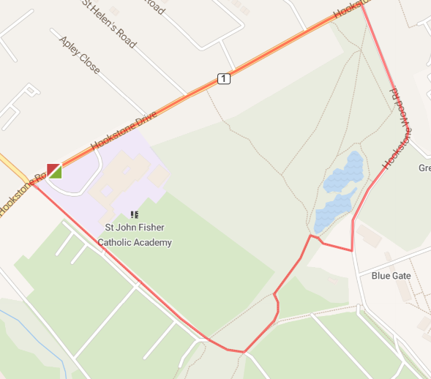

L out of school grounds (use path) – L at traffic lights onto Coach Road – through gate and continue straight ahead (watch for cyclists/pedestrians) – L at end – bear L then R following path to lake – R onto path towards Hookstone Wood Road – L onto Hookstone Wood Road (watch as no footpath on part) – L onto Hookstone Drive – back to base.
SJF – SUMMER ROUTE 1 – 2 MILE

https://gb.mapometer.com/running/route_5516378.html

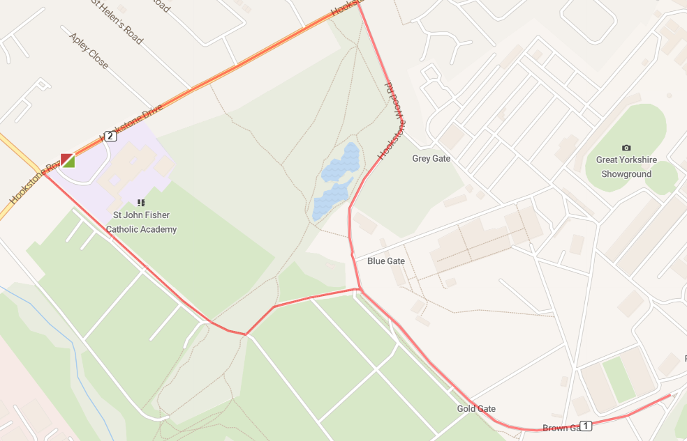

L out of school grounds (use path) – L at traffic lights onto Coach Road – through gate and continue straight ahead (watch for cyclists/pedestrians) – L at end – R after dog poo bin onto road (watch for vehicles – run facing traffic) – follow road down (watch for cattle grid) to gate – turn around and follow road back up (watch for cattle grid) – continue straight onto Hookstone Wood Road (watch as no footpath on part) – L onto Hookstone Drive – back to base.

SJF – SUMMER ROUTE 1 – 3 MILE

https://gb.mapometer.com/running/route_5516382.html

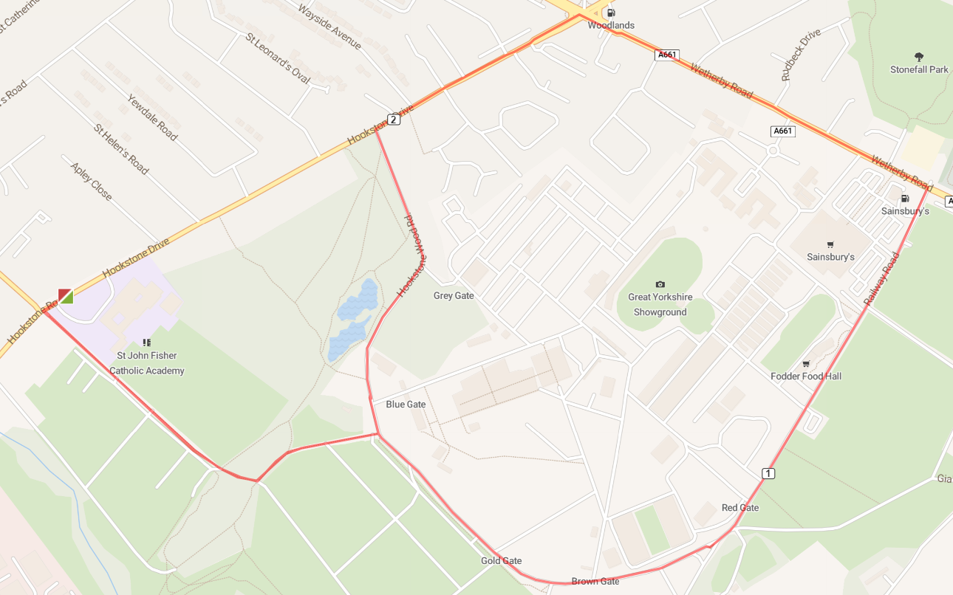

L out of school grounds (use path) – L at traffic lights onto Coach Road – through gate and continue straight ahead (watch for cyclists/pedestrians) – L at end – R after dog poo bin onto road (watch for vehicles – run facing traffic) – follow road down (watch for cattle grid) onto Railway Road, past Fodder and side of Sainsbury’s – L onto Wetherby Road (watch for vehicles) – L onto Hookstone Drive – L onto Hookstone Wood Road (watch as no footpath on part) – R onto Coach Road – R onto Hookstone Drive – back to base.

SJF – SUMMER ROUTE 1 – 4 MILE

https://gb.mapometer.com/running/route_5515547.html

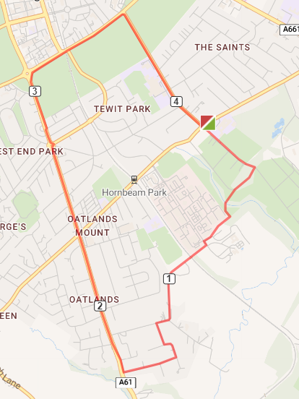

L out of school grounds (use path) – L at traffic lights onto Coach Road – through gate and continue straight ahead (watch for cyclists/pedestrians) – R at end – follow paved path until Hornbeam Park Avenue (opposite Indulge) – cross road – turn L then R quickly at blue sign (Almsford Bank/Stone Rings) – follow path over railway (watch as can be muddy and uneven) – onto paved path to Fulwith Mill (signed Harrogate Railway – watch for speed bumps) – R onto Fulwith Mill Lane (wide road but no footpath so run facing oncoming traffic) – L onto Fulwith Drive – follow road round – R onto Fulwith Road – R onto Leeds Road towards Prince of Wales roundabout (take care crossing roads/junctions/roundabout) – R onto Tewit Well Avenue and immediate L onto Stray path – follow path around edge of Stray – R onto Oatlands Drive to end - cross Hookstone Road – L back to base.

