MARKET WEIGHTON 1 Mile routes

ROUTE A https://gb.mapometer.com/running/route_5265947
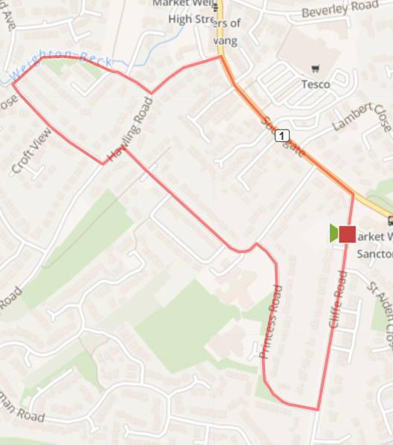
Turn R out of base down Cliffe Road, Turn R onto Princess Road
At junction on Princess Road bear left, Continue on Princess Road to Hawling Rd – turn L
Turn R onto Croft Close, Bear right onto path alongside Beck (don’t go over bridge) Follow Beck path until join Scotts Croft, At junction turn L onto Hawling Road
Turn R onto Southgate, Turn R onto Cliffe Road – back to base
Cautions - very uneven pavements along the route

ROUTE B https://gb.mapometer.com/running/route_5265948.html
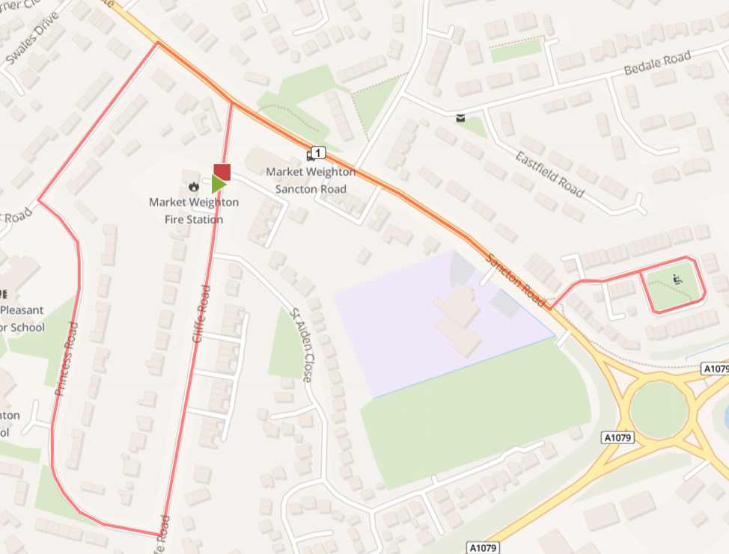
Turn R out of base onto Cliffe Road, Turn R onto Princess Road
At junction bear R onto Princess Road
Turn R onto Southgate – continue (go past road back to base)
Turn L at Kings Court and do a lap of this cul de sac
Bear R back onto Southgate
Turn L onto Cliffe Road – back to base

Cautions - very uneven pavements along the route- use the pedestrian crossing on Southgate

ROUTE C https://gb.mapometer.com/running/route_5265949.html
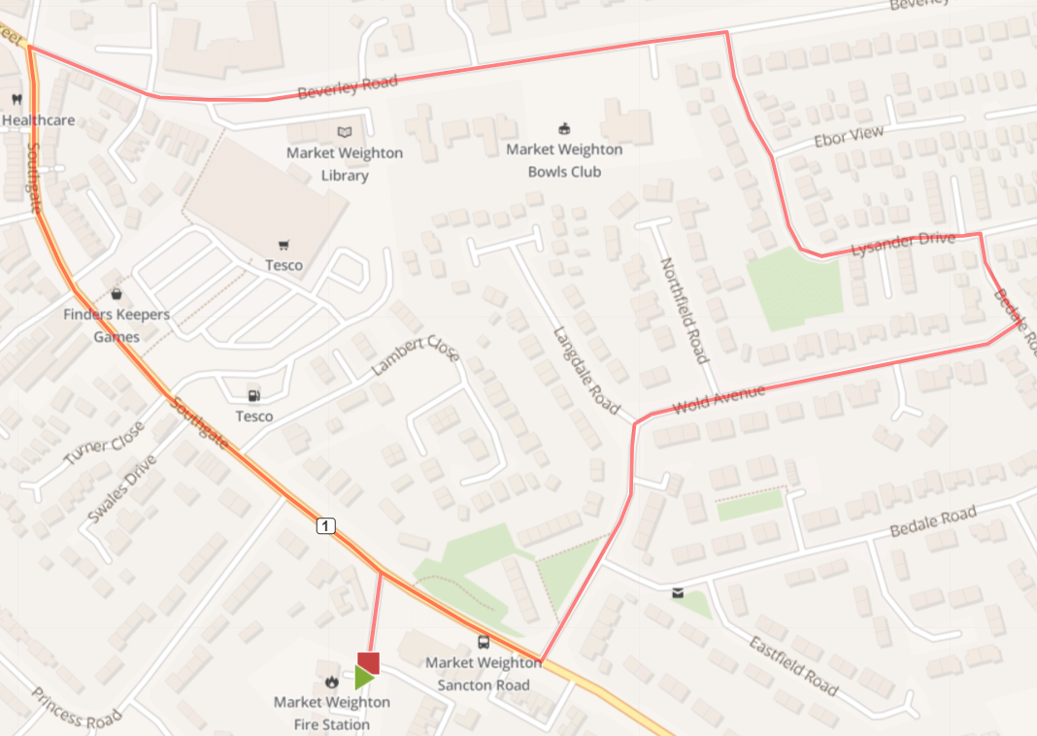

Turn L out of base onto Cliffe Road, Turn R onto Sancton Road
Turn L Langdale Road, Bear R Wold Avenue
Turn L Bedale Road, Turn L Lysander Drive
Turn L Beverley Road, Turn R Southgate
Turn R onto Cliffe Road – back to base

Cautions - very uneven pavements along the route- use the pedestrian crossing on Southgate

ROUTE D https://gb.mapometer.com/running/route_5311545.html
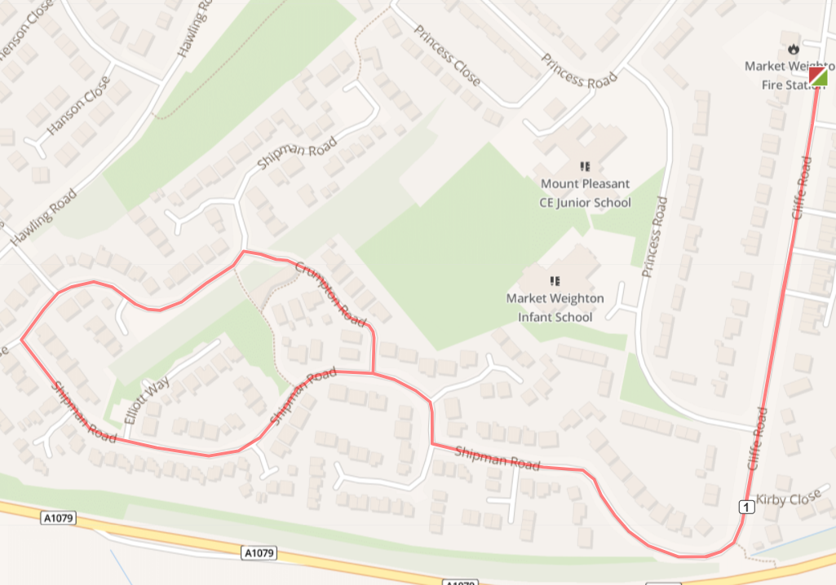
Turn R out of base into Cliffe Rd, Turn R onto Shipman Rd, continue the whole way along Shipman Road (2x R turns) until it becomes Crompton Road. Turn L to re-join Shipman Road, continue on Shipman Road (L turn) following route back to base, L turn onto Cliffe Rd and continue back down to base

Cautions - very uneven pavements.

ROUTE E https://gb.mapometer.com/running/route_5311550.html

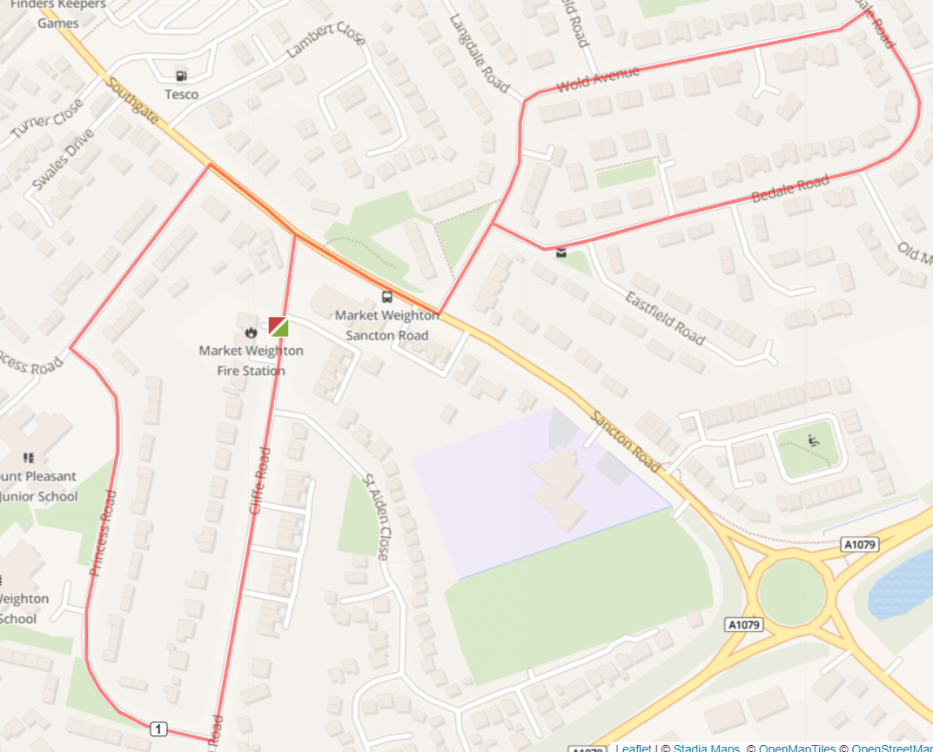

Turn L out of base to the T-junction cross the road and turn R onto Sancton Rd, cross over Sancton Rd using the zebra-crossing. Turn L onto Langdale Rd, cross over the road turn R onto Bedale Rd. Continue to the top of the hill follow the road to the left and take the L turn onto Wold Ave, turn L to join back onto Langdale Rd and continue back down to Sancton Rd. Use the zebra-crossing to cross back over Sancton Rd, continue on Sancton Rd (take care crossing over the end of Cliffe Road T-junction) continue until L turn on Princess Rd turn L to continue on Princess Rd (past MW Infant School) follow the road to the left and turn L onto Cliffe Rd and continue back down to base.
(1 mile distance is reached as route joins Cliffe Rd therefore use route back to base for cool down if required)

Cautions - uneven pavements. Require to cross over roads

ROUTE F - 1 mile MW FM 1 Mile route F . Mapometer.com running route #5396043

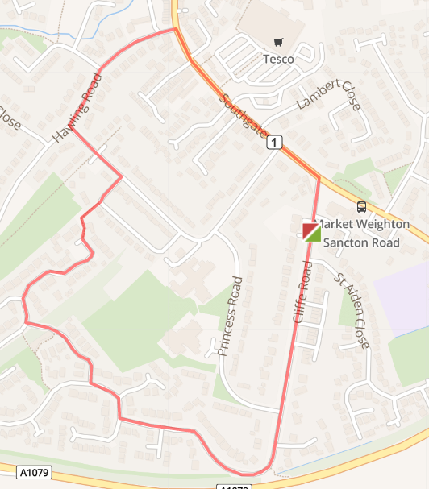

Turn R out of base onto Cliffe Rd, to the end bear R onto Shipman Rd. At the T-Junction divides take R continue Shipman Rd. Take 2nd R onto Crumpton Rd, to T-junction R back onto Shipman Rd. Continue end on Shipman take the snicket path (caution low lighting) leave snicket path onto Princes Close continue straight. Turn L Princess Rd, T-junction R Hawling Rd, T-junction R Southgate, R on Cliffe Rd return to base.

Cautions - very uneven pavements along the route
low lighting uneven ground on snicket path from Shipman Rd to Princes Close
caution cross over to LHS of road as pavement runs out on RHS

