MARKET WEIGHTON 4 Mile Routes

ROUTE A SUMMER https://gb.mapometer.com/running/route_5253725
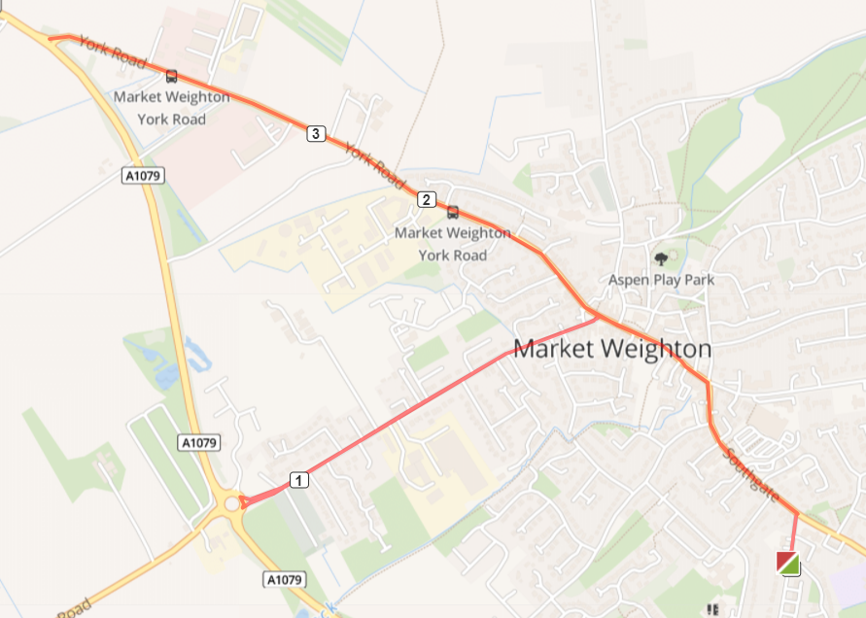
Turn L out of base onto Cliffe Rd, Turn L onto Southgate
Turn L onto High Street, Turn L onto Holme Rd, Continue until the bottom, cross Rd opposite Vets. Continue back up Holme Rd.
Turn L onto York Rd, will need to cross over as path runs out after Ind est, continue until York Rd meets 1079. Turn around. Run back along York Rd onto Market place and High street, Turn R onto Southgate, Turn R onto Cliffe Rd and back to base.

Cautions, uneven paths, use crossing to cross.

ROUTE A ALL YEAR https://gb.mapometer.com/running/route_5319496.html

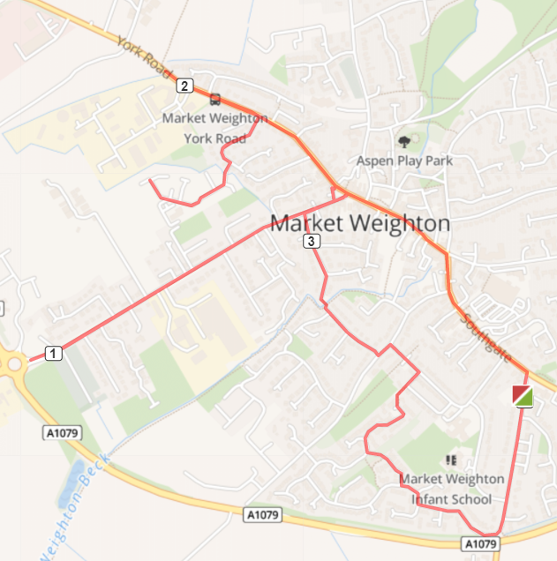
Turn L out of base into Cliffe Rd, Turn L onto Southgate, at the mini-roundabout continue L onto High St continue Market Place, turn L at Giant Bradley statue onto Holme Road run to the end and back to Giant Bradley, L onto York Rd, run to last house where street lights stop, turn back and take R turning on Northgate Vale, R onto Medforth St, run to the end on the cul de sac (past GP Practice) return to York Rd. R head back to Market Place, R onto Linegate to Holme Rd. Cross over to take L turn onto Glenfield Ave. Run to end, cross small bridge over beck (low light single file). Onto Croft Close, L Hawling Rd, cross over R Princes Rd, turn R Princes Close at the corner head R on the cut through to join Shipman Rd, L onto Crumpton Rd, L to rejoin Shipman Rd, L Cliffe Rd return to base.
Cautions - uneven pavements, road crossing, low lighting over beck and cut through to Shipman Rd.

ROUTE B https://gb.mapometer.com/running/route_5259497
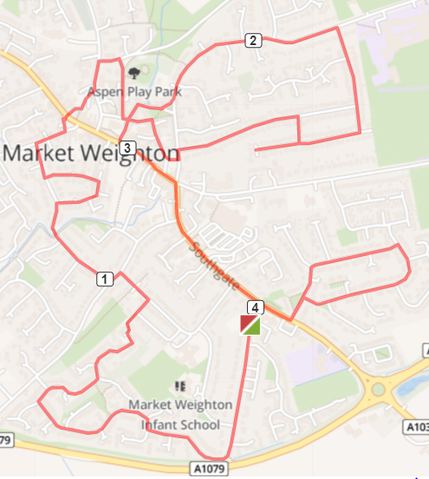

From base turn R onto Cliffe Rd – leads onto Shipman Rd Bear R again keeping on Shipman Rd (past Steel Close on R) Turn R onto Shipman Rd (Potter Close will be on L) Continue past Crumpton Rd exit – head to path in left-hand corner – cut through to Princess Close Caution: Poor lighting. Straight on to Princess Rd – Turn L Turn L onto Hawling Rd, Take first R Croft Close – over bridge/beck onto Glenfield Ave
Bear R onto Beech Close – leads into Ash Grove, then R back onto Glenfield Ave Turn R Holme Road, L Linegate to cross main road – into car park turn L onto Londesborough Rd, R Hall Rd – (no road sign – but it is before park) R Station Rd L Church Close, immediate L St Helen’s Square, bear L onto The Green
L Spring Rd, Turn R Hill Rise – go as far as you can go onto Hill Rise Close then turn R Hill Rise Drive (go all the way to the end even tho a cul-de-sac) , turn group back at end, then L onto Hill Rise Drive, L Hill Rise, L onto Finkle St, then almost directly opposite onto R The Archway – follow road round back to Church, L Church Side, L High St (use crossing) R Southgate (use crossing after Tescos - not first one) L Langdale Rd, R Bedale – follow road all way round to rejoin Langdale Rd, R onto Sancton Rd, L Cliffe Rd – back to base

Cautions: Uneven paths on some parts of route

ROUTE C SUMMER https://gb.mapometer.com/running/route_5259499
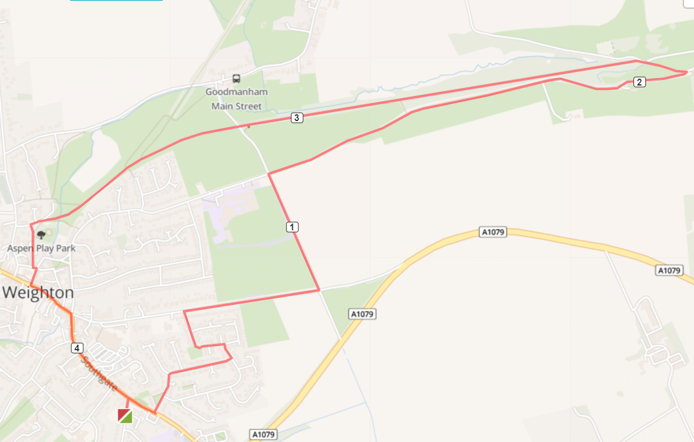

Base – L onto Cliffe Road – R onto Southgate – L onto Langdale Road – R onto Wold Avenue – L onto Bedale Road – L onto Lysander Drive – R onto Beverley Road Use RHS, Uneven Path – L onto Humber Street (Yorkshire Water Works) Very Uneven Path – R onto Spring Road No Path, Stay Right– L Yorkshire Wolds Way (to Goodmanham) – L onto Hudson Way Gate, Uneven Track – Continue onto Hall Road – L onto path after Park – Continue onto Station Road – L Church Close – R Church Side Bollards – L onto High Street Use Crossing – R onto Southgate – R onto Cliffe Rd - Base

Cautions in red

ROUTE C ALL YEAR https://gb.mapometer.com/running/route_5311631.html
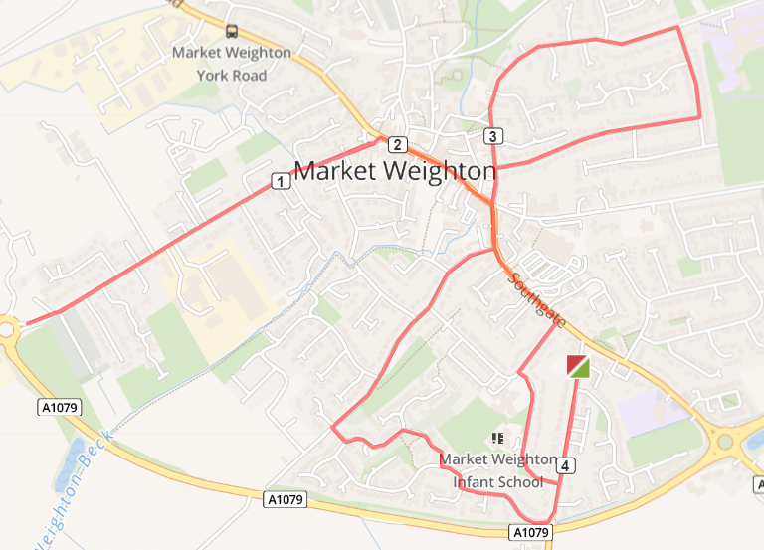
Turn R out of base into Cliffe Rd, Turn R onto Princess Rd. After passing the school turn R on Princess Road to head toward Southgate, turn L onto Southgate, roundabout L High St onto Market Place, L Holme Rd continue to roundabout at end STOP and return Holme Rd T-junction R Market Place, High St, roundabout L Finkle St, R Hill Rise L Spring Rd continue to re-join Finkle St back to roundabout, straight over cross over road to turn R Hawling Rd ( use crossings) continue road becomes Sweep Rd, take cutting on L through to Shipman Rd, L Shipman Rd, R Crumpton Rd, L Shipman Rd continue L Shipman Rd until L to rejoin Cliffe Rd back to base.

Cautions - uneven pavements, low lighting on cut through to Shipman Rd, crossing main roads

ROUTE D https://gb.mapometer.com/running/route_5267412
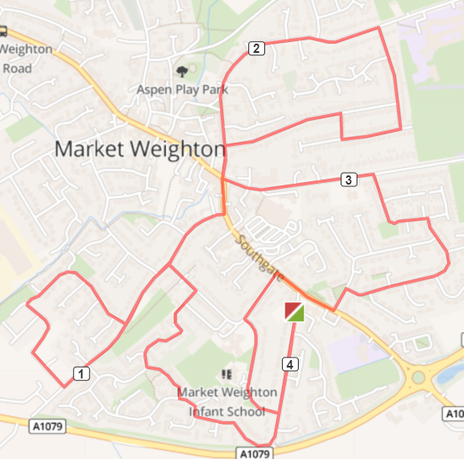

Base – R onto Cliffe Rd – R onto Shipman Road – At the end of Shipman Road, take the cut through onto Princess Close – L onto Princess Road – L onto Hawling Road – Continue on Hawling Road Use RHS – R onto Wicstun Way and follow all the way round – L onto Hawling Road – L onto Southgate – At Roundabout Straight onto Finkle Street – Continue onto Spring Road High Kerb Drop – R onto Hill Rise – Continue onto Hill Rise Close – R onto Hill Rise Drive – R onto Hill Rise Drive – L onto Hill Rise – L onto Finkle Street – At Roundabout L onto Beverley Road Use RHS – R onto Lysander Drive – R onto Bedale Road – L onto Langdale Road – R onto Southgate Use Zebra Crossing – L onto Princess Road – L onto Princess Road at school – L onto Cliffe Road - Base
Cautions in red

ROUTE E https://gb.mapometer.com/running/route_5311623.html
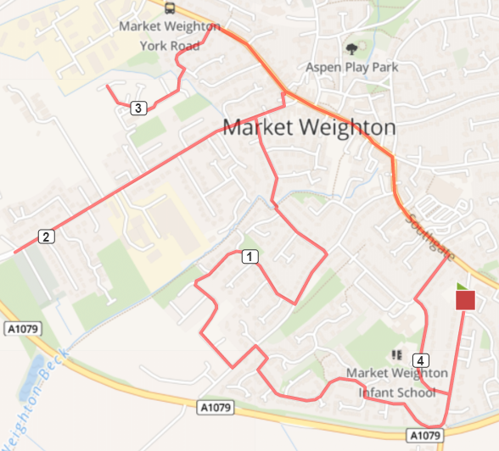
Turn R out of base Cliffe Rd, turn R Shipman Rd R at T-junction continuing Shipman Rd, R at T-junction Shipman Rd, next L taking the cut through onto Hawling Rd, T-junction L Sweep Rd/ Hawling Rd, R Butler Dr, R Wicstun Way follow all way round until re-join Hawling Rd turn L. Turn L Croft Clse, continue straight over little bridge over Weighton Beck onto Glenfield Ave, T-junction L Holme Road run to end at roundabout STOP a return Holme Rd to T-junction L York Rd, L Northgate Vale , R Medforth St continue to end STOP and retrace route back to York Rd, contiune Market Place, High Street roundabout R Southgate, R Princess Rd, L Princess Rd, L Cliffe Rd back to base.

Cautions: uneven paths, low lighting in some areas, crossing main roads

ROUTE F MW FM 4 Mile Route F . Mapometer.com running route #5396059

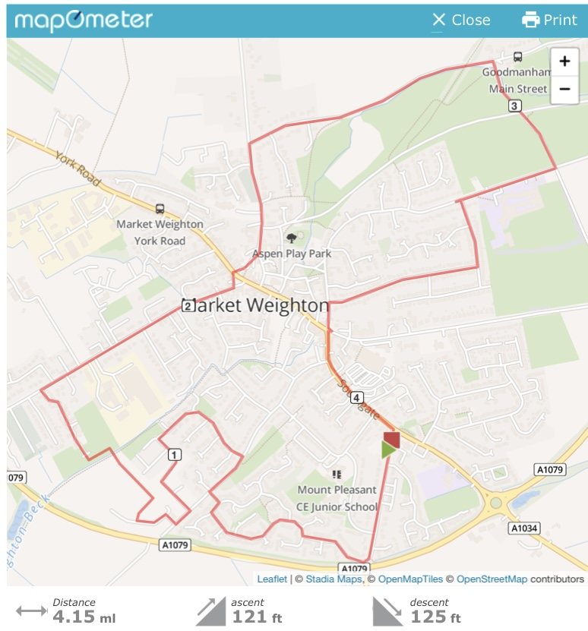

Turn R out of base onto Cliffe Rd, to the end bear R onto Shipman Rd. At the T-Junction where road divides take R to continue Shipman Rd, continue to follow Shipman Rd T-junction R then L take the snicket pathway from Shipman through to Sweep Rd (caution bollards, low light) R on Sweep Rd, L onto Wicstun Way. Follow Wicstun Way keep turning L until turns in Butler Drive, R Sweep Rd, to end R Ombler Drive, 1st R Beales Close over Weighton Beck, L Coperland Crescent, R Sandholme to end R Holme Rd. At end of Holme Rd, cross over opposite bus stop, through car park onto Londesbrough Rd. Follow and then R onto Goodmanham Rd, carry on underbridge (caution no footpath) R onto Red Lane (caution no Footpath) R onto Spring Rd, L Hill Rise, R down Hill rise, L Finkle st, cross over onto Southgate, follow and take R onto Cliffe Rd back to base.
Cautions – bollards, narrow path low light on snicket from Shipman to Sweep Lane, uneven pavements along the route, new road surface areas with high kerbs, low lighting (Beales Close area), no pavement low/no lighting on part Goodmanham Rd & Red Lane.

