SJF – SUMMER ROUTE 2 – 1 MILE

https://gb.mapometer.com/running/route_5517122.html

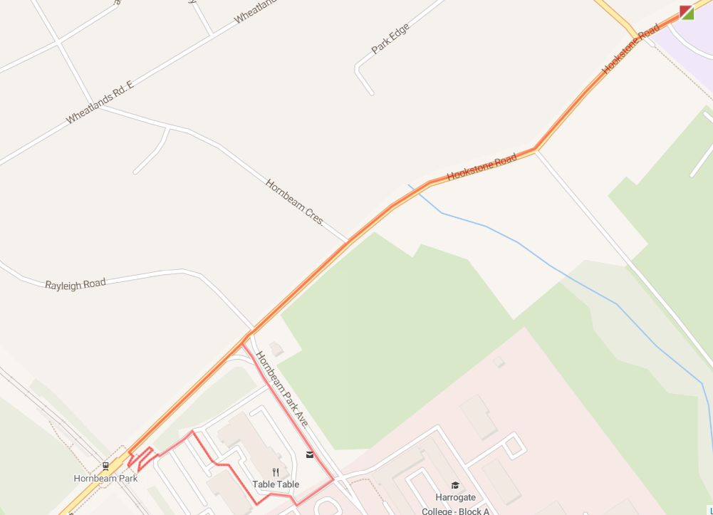

L out of school grounds (use path) – use crossing to cross onto Hookstone Road – L towards Hornbeam Park – cross Rayleigh Road continuing to railway bridge – use crossing over Hookstone Road and then follow sloped zig zag path down towards station car park – L at bottom then R following path between Premier Inn and Nursery – L at The Park – L onto Hornbeam Park Avenue – use crossings to cross Hookstone Road – R following Hookstone Road back to base.

SJF – SUMMER ROUTE 1 – 2 MILE

https://gb.mapometer.com/running/route_5517100.html

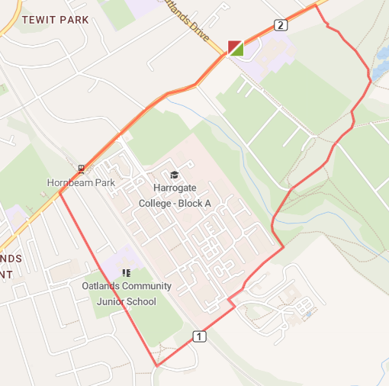

L out of school grounds (use path) – use crossing to cross onto Hookstone Road – L towards Hornbeam Park – cross Rayleigh Road continuing to railway bridge – use crossing over Hookstone Road – L towards M&S – after Beechwood Grove L onto path alongside Oatlands School – L onto Harrogate Ringway following path over railway (watch as can be muddy and uneven) – at end L then quick R crossing road to continue on Harrogate Ringway – bear L crossing bridge following path up towards Coach Road – follow path and bear L at blue sign (watch for low tree branches) – follow path up – L onto
Hookstone Drive – back to base.

SJF – SUMMER ROUTE 1 – 3 MILE

https://gb.mapometer.com/running/route_5514775.html

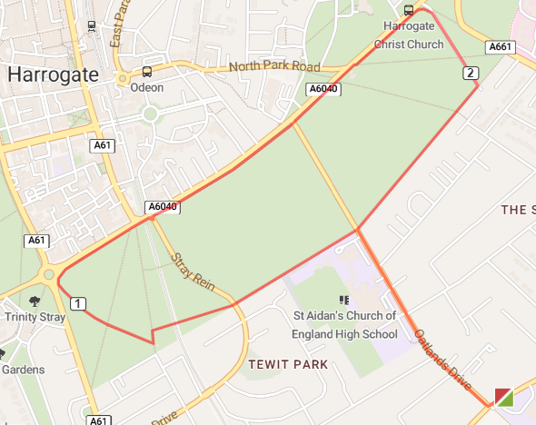

L out of school grounds (use path) – use crossing to cross Hookstone Drive onto Oatlands Drive – L onto Slingsby Walk – cross Stray Rein following the path over the bridge – L then R following Slingsby Walk across The Stray – R* and follow path along The Stray to the Empress Roundabout – R onto path where parkrun starts – R onto Slingsby Walk – L onto Oatlands Drive to end - cross Hookstone Road – back to base. (*If muddy cross Prince of Wales roundabout and run along York Place to crossing near Empress Roundabout – cross to join parkrun path across The Stray)
SJF – SUMMER ROUTE 1 – 4 MILE

https://gb.mapometer.com/running/route_5514774.html

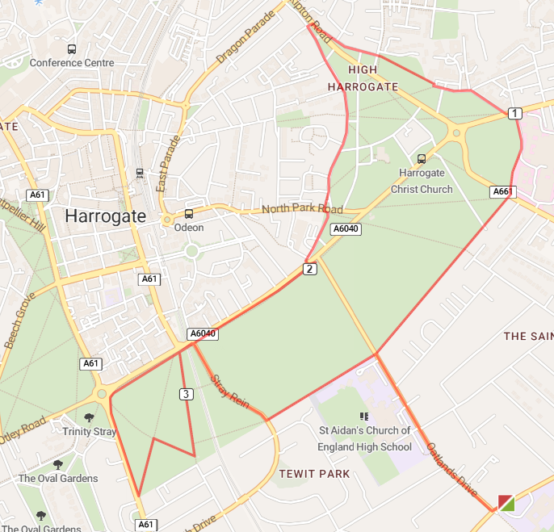

L out of school grounds (use path) – use crossing to cross Hookstone Drive onto Oatlands Drive – R onto Slingsby Walk – cross over Wetherby Road – follow path with Hospital on your R – cross Knaresborough Road – bear R onto Granby Road, then onto Devonshire Place, finally merging with Skipton Road – cross over at Deli Bar (opposite Westmoreland Street) – L onto Regent Parade, onto Park Parade – cross North Park Road following Park Parade in front of Cedar Court Hotel* – use crossing to cross York Place – R onto The Stray path down to Prince of Wales roundabout – L onto path adjacent to Leeds Road – at end of The Stray immediate L onto Milton Way – R onto Slingsby Walk (towards Tewit Well Road) – L onto Cherry Tree Walk (towards York Place) – R onto path – R onto Stray Rein – L onto Slingsby Walk – R onto Oatlands Drive to end - cross Hookstone Road – back to base. (*If muddy continue on York Place and cross at Prince of Wales roundabout)

