
Step by Step Instructions for accessing Zoom via laptop (without Zoom App).
- A few minutes before the session in due to start, click on the link provided in either email or on facebook group, which will look similar to this:
https://zoom.us/meeting/register/v5ItdeqvqTsiDnyTYuAGtgm_RWiWVV2z3w?fbclid=IwAR0p1M9fTWU9F2JgD6rww7TFR3780uOhwN048dxB8VdxxAb24qrb1b2bC34
- The following page will appear (will have different date/time and session type):
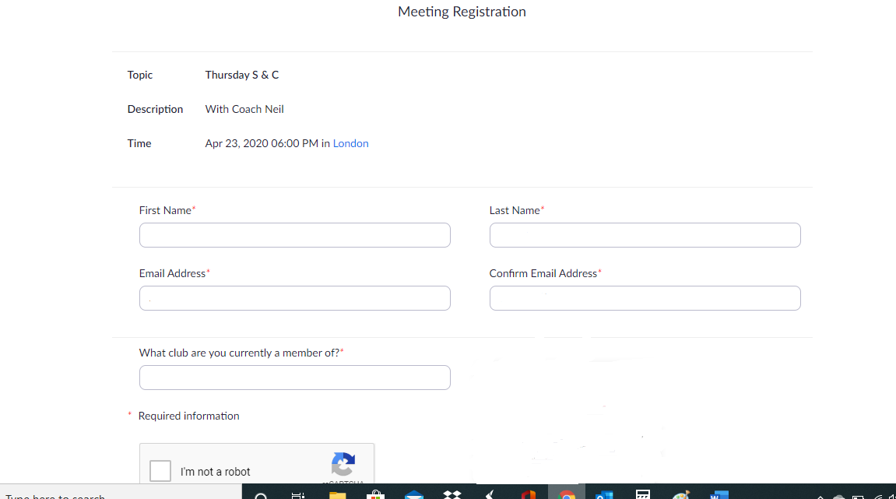
- Complete all boxes including the “I’m not a robot” tick box. We ask you to register so we can demonstrate how many members we have supported through these virtual sessions.

- The following page will appear, click open url
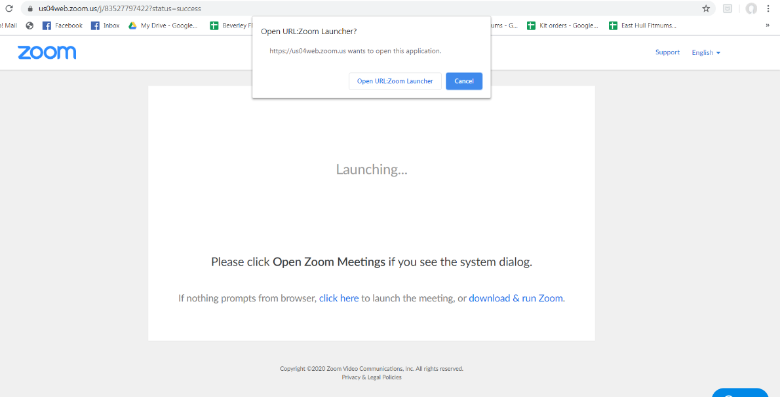

- The next page will appear, enter the password you have been provided.
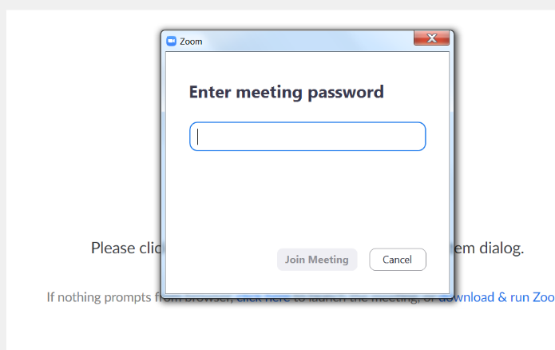

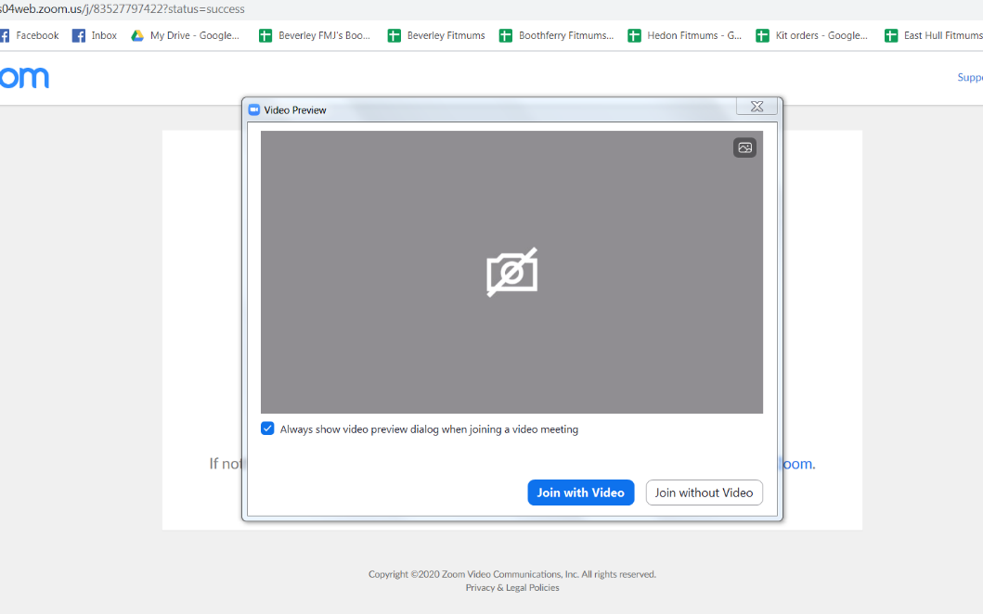
- The following page appears, you can now choose to use video or to remain unseen.

- The following screen shows that you are in a waiting room, the coach will allow members to enter before the session starts.
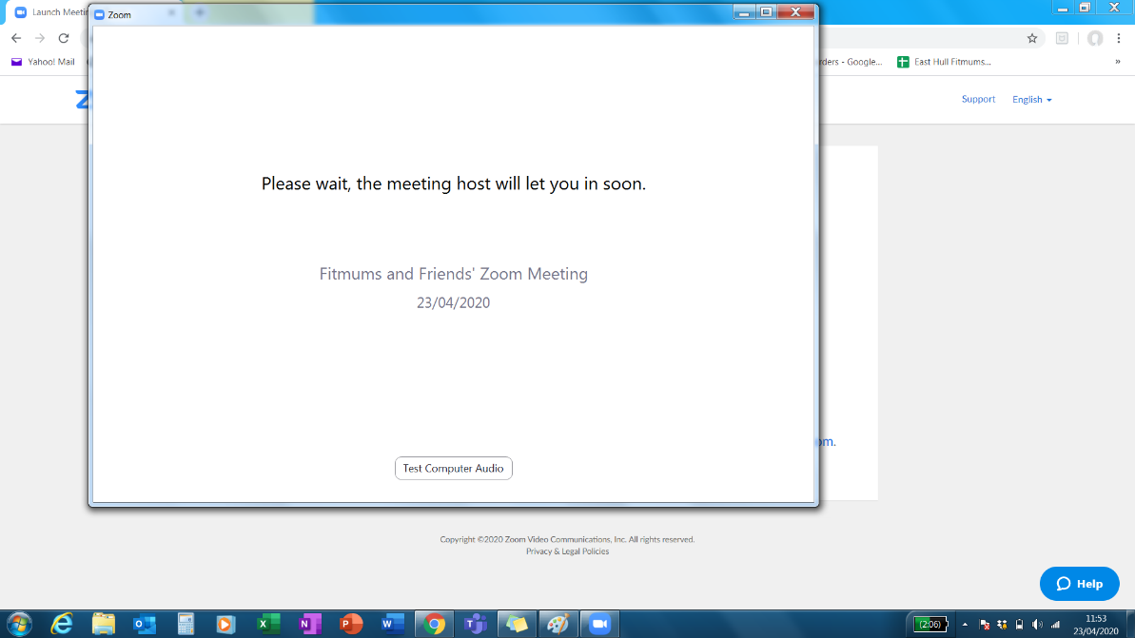

- During the video call you can see the bar at the bottom of the screen. With the following functions that I have highlighted:
Red arrow – Join audio so the coach and participants can hear you (optional)
Blue arrow – Start video so the coach and participants can see/not see you (optional)
Green arrow – Reactions so you can show thumbs up or clapping sign (optional)
Yellow arrow – Leave meeting. You can leave at any time, at the end of the session choose this or the coach will end the session for all.
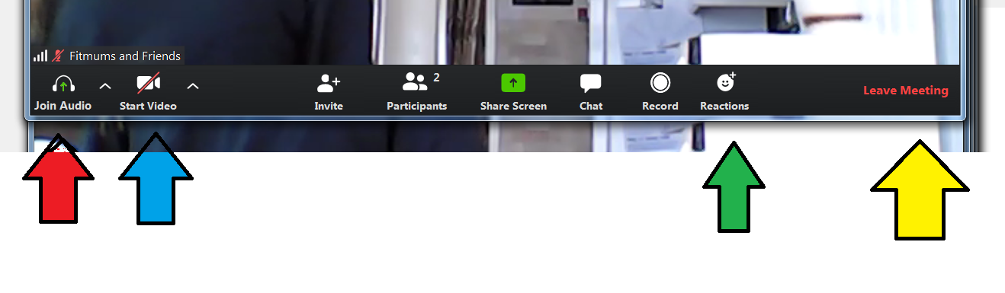
That is it! Zoom in a nutshell. Hope it helps, please get in touch if you need more help.

