

Step by Step Instructions for accessing Zoom App.
- A few minutes before the session in due to start there are 2 ways to access the session.
Option 1 click on the link provided in either email or on facebook group, which will look similar to this.
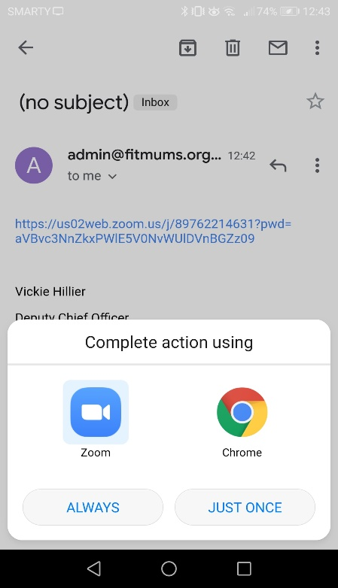
https://zoom.us/meeting/register/v5ItdeqvqTsiDnyTYuAGtgm_RWiWVV2z3w?fbclid=IwAR0p1M9fTWU9F2JgD6rww7TFR3780uOhwN048dxB8VdxxAb24qrb1b2bC34
The screen will appear like this asking you to choose a way to open the link. Click Zoom and always.

- OR option 2 Open Zoom app and screen below will appear. Click join.

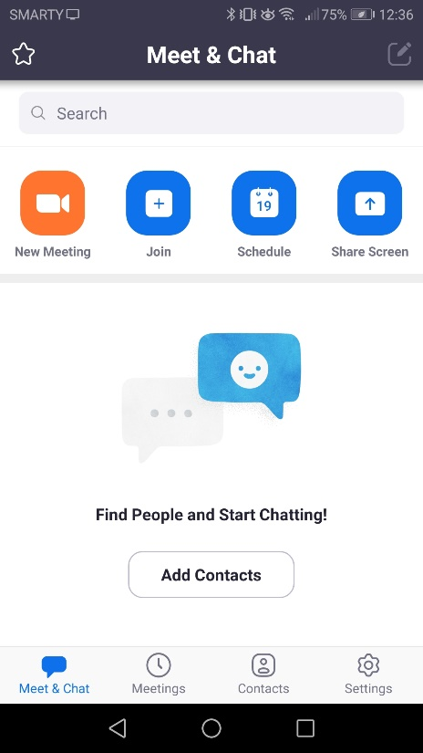

- The screen below (or similar) will be displayed. Enter Meeting ID provided in top box. At this point before you click join meeting, you will have the option to choose if to allow video and sound (see image on right).
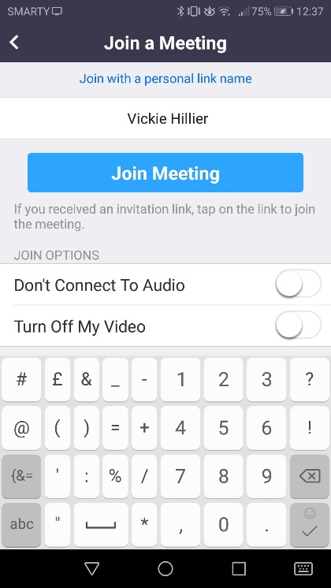
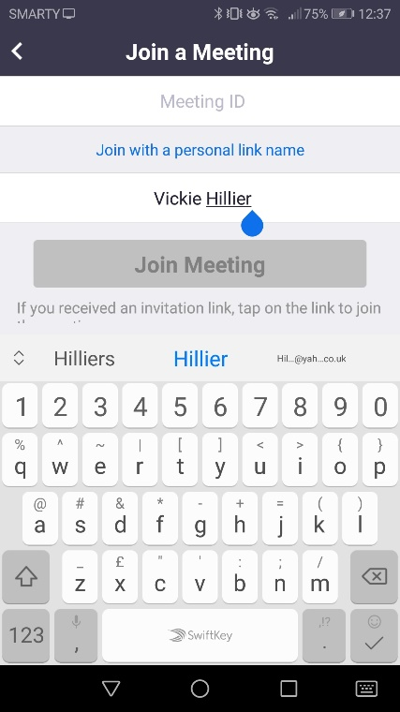

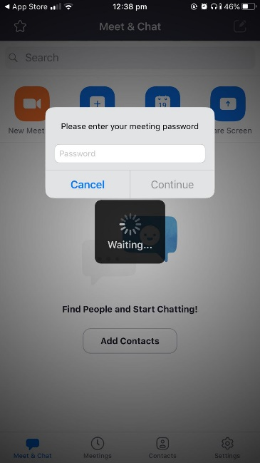
- If you entered the meeting ID rather than using the link, it will ask
for the password. If you used the link, it will not.

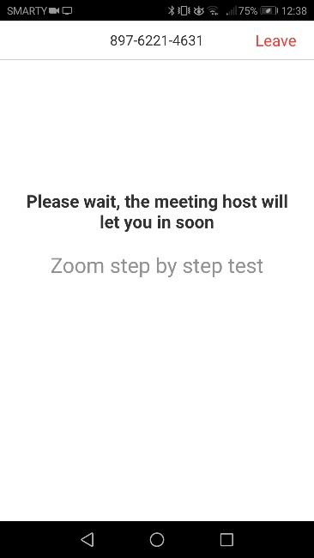
- You will then be placed in the waiting room for the host/coach to let
you in.

- Once you are in the meeting, at the bottom of your screen you can choose to start/stop video or audio.
Image on the left is iphone, on the right is android.

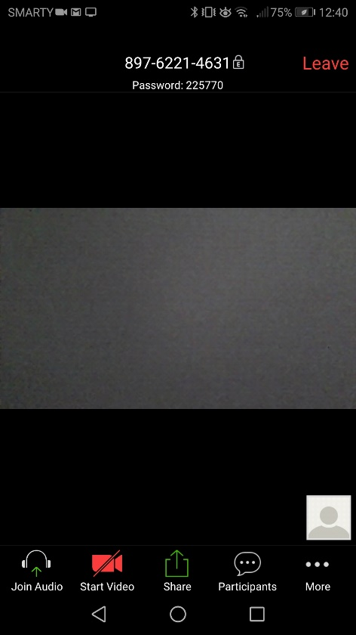
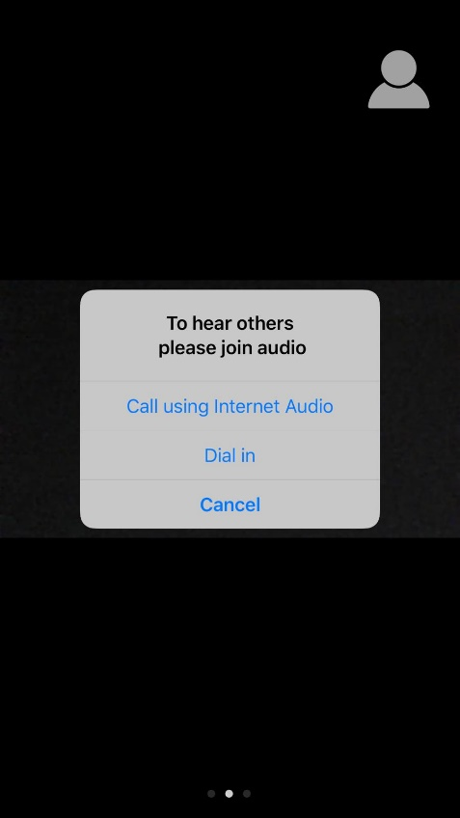

- There are also other options (by clicking the 3 dots on the bottom right hand side on android). A screen similar to the one
below will appear.
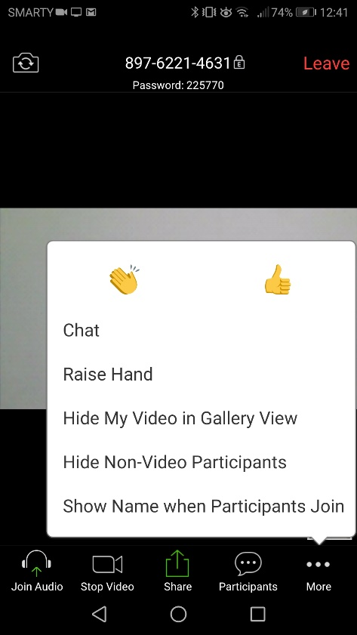
Chat means you can send a message to the coach/host or you
can show a clap/waving hand.

- In red, there is a leave meeting option (top right on Android a=image above). You can do this at any time, but once the session is over you choose this. The coach/host can also end the meeting once the session is over.
That is it! Zoom in a nutshell. If you need any further help please get in touch.

