 | HINGE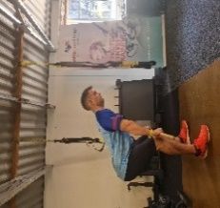 | SQUAT  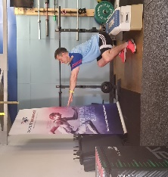 | LUNGE  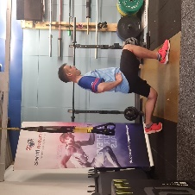 | BRACE AND  ROTATE | PUSH  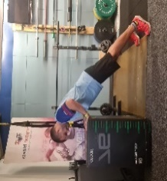 | PULL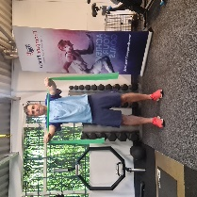
 | Neutral back | Neutral Back | Good Posture | Good posture | Core engaged | Posture
 | Hips above knees | Knees/toes aligned | 90’ Knees | Core engaged (Glutes) | Elbows tucked | Shoulders down/back
 | Legs unlocked | Lead with hips | Back Knee kisses floor | Belly Breathing | Connect upper/lower | Quick in, slow out
 | Hamstrings ‘stretched’ | Feet fully grounded | Solid push off front heel | Shoulders down/back
 | Hamstrings ‘stretched’ | Aim >Parallel |  | Slow controlled
Level 1 | Glute Bridge | Zombie Squat | Split Squat | Timed Plank (20s on 20 off etc up to 60s) | Wall push up | Pull aparts
Level 2 | Glute Bridge raise on 1 leg lower on 2 legs | Prisoner Squat | Reverse lunge | 3 Point plank var. (no hip shift) | Incline push up (Kneeling) | Seated/Standing Rows
Level 3 | Single leg Bridge | Overhead Squat | Forward lunge | Slow Dynamic Planks (Mountain climbers etc) | Push up lowers (Slow eccentric) | Single arm rows
Level 4 | Hinge (Dowel etc) | Goblet Squat | Walking Lunge | Deadbugs (ensure neutral pelvis) | Full push ups | Bent over rows
Level 5 | Hinge resisted (Bands, KB etc) | Tempo Squat (Slow with hold) | Resisted Lunge | Med Ball | Band resisted push ups | Inverted Rows
Level 6 | Single leg hinge | Tempo Squat (Fast) | Rear foot elevated Split squat | Palov holds and presses (Band) |  | Assisted pull ups
Level 7 | Broad Jumps | Squat Jump | Split squat ‘scissor’ jump | Surrender | Plyo push ups | Pull ups



