MARKET WEIGHTON 2 mile routes

ROUTE A https://gb.mapometer.com/running/route_5265950.html
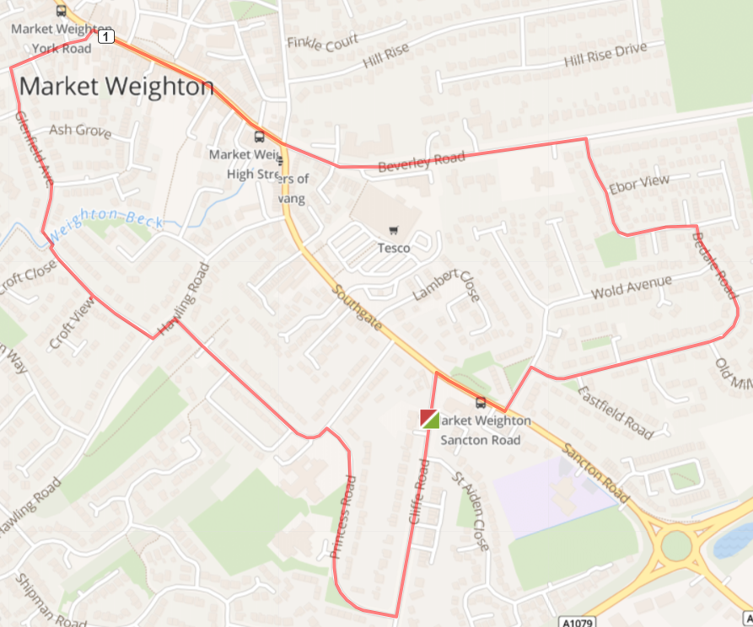
Turn L out of base onto Cliffe Road,Turn R onto Sancton Road Turn L onto Langdale Road, Bear R onto Bedale Road. Follow road round til it joins Lysander Drive – bear L here
Turn L onto Beverley Road,Continue onto High Street then MarketPlace. L onto Holme Road, L onto Glenfield Avenue. Across bridge to Croft Close, Turn L onto Hawling Road
Turn R onto Princess Road, Keep R on Princess Road (follow the path in front of the school) L onto Cliffe Road – back to base on Left

Cautions - very uneven pavements along the route - use the pedestrian crossing Marketplace

ROUTE B https://gb.mapometer.com/running/route_5265951.html
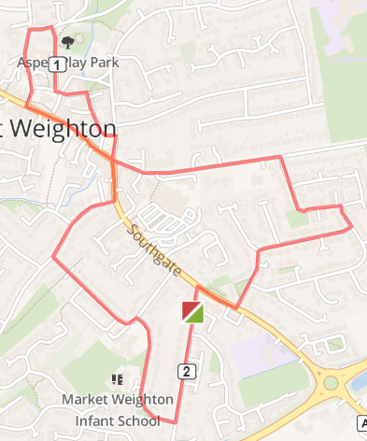
Turn L out of base onto Cliffe Road, Turn R onto Sancton Road Turn L onto Langdale Road, Bear R onto Bedale Road. Follow road round until it joins Lysander Drive – bear L here. Turn L onto Beverley Road Turn R onto Finkle Street, Turn L The Archway no street lighting! Continue onto Church Close Turn R onto Station Road at side of the church, Turn L onto Hall Road, Turn L onto Londesborough Road, Turn L onto Marketplace – onto High Street Turn R onto Southgate, Turn R onto Hawling Road Turn L onto Princess Rd, Bear R to continue on Princess Rd Turn L onto Cliffe Road – back to base on left

Cautions - very uneven pavements along the route- use the pedestrian crossing on Southgate

ROUTE C https://gb.mapometer.com/running/route_5265952.html
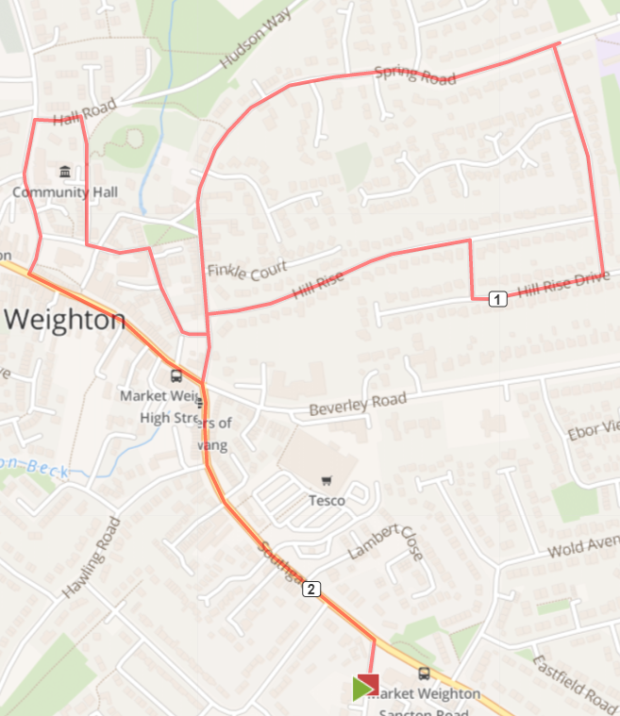

Turn L out of base onto Cliffe Road, Turn L onto Southgate. Cross over road using the zebra crossing before the mini-round to transfer to RHS of road. Cross over the end of Beverley Road to go straight on to Finkle Street – follow on to Spring Road R onto Hill Rise. Continue onto Hill Rise Close, R onto Hill Rise Drive, L onto Hill Rise L onto Finkle Street, cross road First R onto The Archway, Take R onto Station Road, L onto Hall Road L onto Londesborough Road, L onto Marketplace – goes onto High Street Turn R onto Southgate – onto Cliffe Road back to base

Cautions - very uneven pavements along the route poor lighting around the Archway, crossing main roads

ROUTE D ALL YEAR https://gb.mapometer.com/running/route_5310179.html
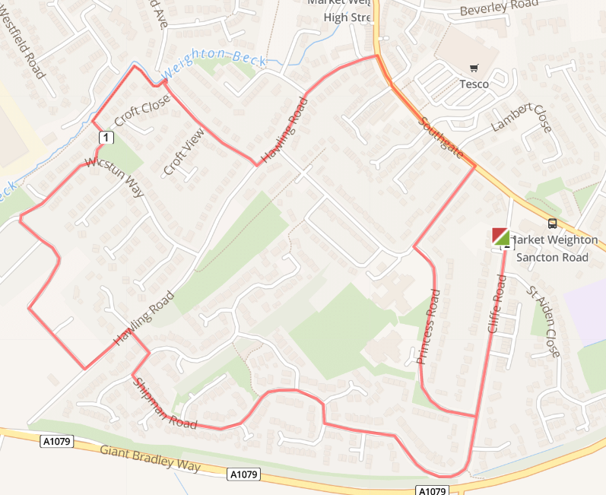
Turn R of of base into Cliffe Rd, Turn R onto Princess Rd. After passing the school turn R on Princess Road to head toward Southgate, turn L onto Southgate, Turn L onto Hawling Road, turn R onto Crofts Close continue straight on to follow the footpath round alongside Weighton Beck (caution narrow). Continue until a L turn onto Wicstun Way, at the T-junction turn R continuing on Wicstun Way, continue to follow Wicstun Way (1 left turn) L onto Butler Drive, L onto Hawling Rd. After a short distance (Sweep Rd) take the cut through on the R, then turn R onto Shipman Road then L to follow Shipman Rd all the way back (1 left turn) continuing round until turn L onto Cliffe Rd and continue back down to base.

Cautions - uneven pavements, single file route, uneven grass verges along the route.

ROUTE D SUMMER https://gb.mapometer.com/running/route_5259486.html
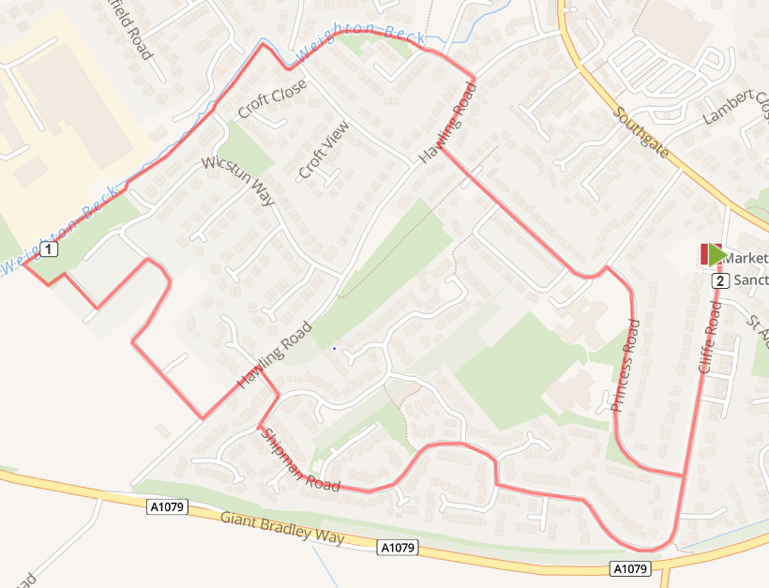
Turn R of of base into Cliffe Rd, Turn R onto Princess Rd, follow it round and turn R onto Hawling Rd, Turn L onto Scotts Croft, follow the footpath round alongside Weighton Beck (caution narrow). Continue all the way, continue on off road track and onto grass park area and loop round on the green. From the green area turn R on Cooper St, continue L Cooper St, turn R Wicstun Way, L onto Butler Drive, L onto Hawling Rd. After a short distance take the cut through on the R then turn R onto Shipman Road follow Shipman Rd all the way back round until turn L onto Cliffe Rd and continue back down to base.

Cautions - very uneven pavements, single file route uneven off road/grass track along the route

ROUTE E https://gb.mapometer.com/running/route_5311566.html
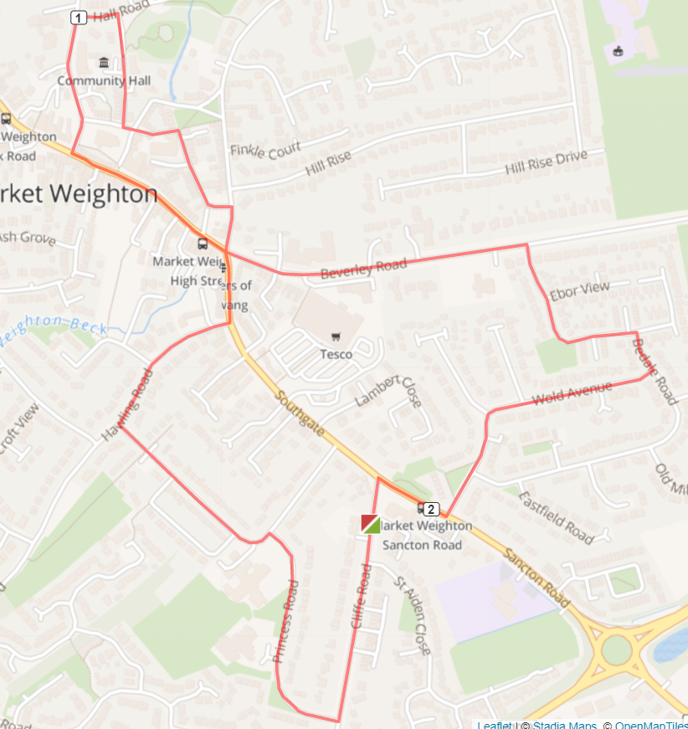
Turn R out of base onto Cliffe Rd, turn R Princess Rd continue L on Princess Rd, until T-junction Hawling Rd turn R continue to T junction Soutgate turn L (roundabout) onto High St continuing into Market Place. Cross over zebra-crossing turn R Londesborough Rd turn R Hall Rd, turn R onto Station Rd (pathway alongside play park) T-junction L Church Close, continue onto The Archway, turning R to continue on The Archway and follow route T-juction Finkle St turn R continue back to roundabout turn L Beverley Rd, continue uphill until R turn Lysander Drive continue until R turn Bedale Rd, then R Wold Ave, L Langdale Rd, T-junction Sancton Rd, use zebra-crossing cross Sancton Rd turn L back onto Cliffe Rd, back to base.

Cautions: uneven paths, low lighting by play park path, crossing main roads.

ROUTE F - 2 mile MW FM 2 Mile Route F . Mapometer.com running route #5396045

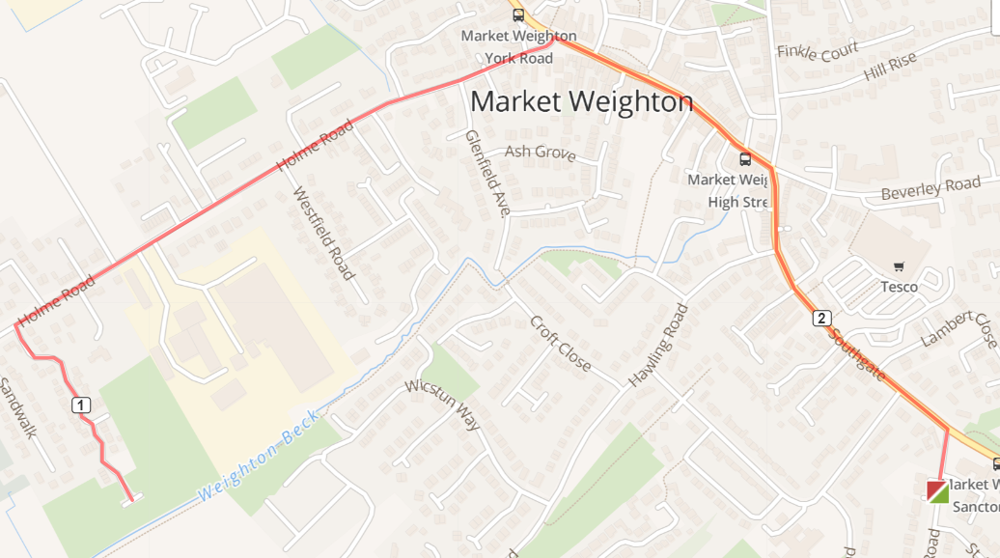

Turn L out of base onto Cliffe Rd, T-junction L onto Southgate. At the min-roundabout L onto Highstreet continue onto Market Place. L Holme Rd. Take 9th turn L onto Sandholme continue to end of Sandholme, then retrace back, R Holme Rd, R Market Place onto Highstreet, R Southgate, R Cliffe Rd to base.

Cautions - uneven pavements along the route
Crossing over road ends

