Humber Athletic Association
46th Annual Humber Cross Country Championships
(Under UKA. & E.C.C.A Rules Permit/licence No.CC2021/0173
Saturday 8th January, 2022
Costello Stadium, Hull, HU4 6XQ

Championship medals for the first 3 runners in all races and the first 3 teams of affiliated clubs in all races.
Teams - 3 to score in all races except Senior Men, which is 6 to score.
First 3 eligible athletes per club/school (SM - 6) to constitute 'A' team and pro rata.
Championship medals to the first 3 Veterans in each Senior race.
There will be Non Championship races for Under 11's.

Age  Group | Age Qualification  (on 31/08/21) | No. required  to score a team | Approximate  Distance | Approximate  Time | Entry  Fee
Under 11 Girls | 9 or 10 years on 8th Jan 2022 | Three | 2000m | 11:15 | £5.50
Under 11 Boys | 9 or 10 years on 8th Jan 2022 | Three | 2000m | 11:15 | £5.50
Under 13 Girls | 11 on 8th Jan 2022 or 12 years | Three | 3000m | 11:40 | £6.50
Under 13 Boys | 11 on 8th Jan 2022 or 12 years | Three | 3000m | 11:40 | £6.50
Under 15 Boys | 13 or 14 years | Three | 5000m | 12:10 | £6.50
Under 17 Women | 15 or 16 years | Three | 5000m | 12:10 | £6.50
Under 17 Men | 15 or 16 years | Three | 6500m | 12:30 | £6.50
Junior Women * | 17,18 or 19 years | Three | 6500m | 12:30 | £7.50
Under 15 Girls | 13 or 14 years | Three | 4500m | 13:05 | £6.50
Senior Men | 20 years and over | Six | 12000m | 13:25 | £7.50
Junior Men * | 17,18 or 19 years | Three | 8000m | 14:05 | £7.50
Senior Women | 20 years and over | Three | 10000m | 14:05 | £7.50
*NB Juniors (Men & Women) who have their 20th birthday on or before 31st December 2022 MUST compete in the Senior Championship if they are to be considered for selection for the UK CAU Inter County Championships as they are run under IAAF Rules.

Competitors must run in their own age groups (except Veterans who run in their respective Senior Event).
Under 11's do not need a County Qualification, as their event is not of championship status.
Under 11's will run together but Girls and Boys will be separated in the results.
Ages taken as at midnight August 31st/September 1st, 2021. Year 6 pupils who have reached the age of 11 between that date and the date of competition must compete as under 13's.

All competitors, except Under 11's, must have a Humber Qualification immediately prior to the Championships - this rule may be relaxed, on application to the entry secretary, for Junior Qualification, (either by birth, or 9 months residence in the Unitary Authorities which form Humber) aged athletes and younger {UKA Rule 9 (10)} but it does not confer a county qualification.

Humber teams for the UK CAU Inter County Championships, at Prestwold Hall, Prestwold Loughborough LE12 5SH in 2022 will be selected later (all age groups except U11’s). Athletes who do not compete in the County Championship must have an extremely good reason for not doing so, if they are to be considered for Humber teams. Date of UK CAU Inter- Counties Championships is 12th March 2022.

Only the first 6 in each race will have automatic selection for the Inter County Championships.

Closing Date – 23..59 (midnight) on Monday 27th December, 2021 – please submit earlier if possible.

Entry via Online only https://forms.gle/VegVGaBdcJNcAFSs8

Enquiries to Allison English ally@fitmums.org.uk

Please paste the link into a browser if necessary.

Humber Athletic Association
46th Annual Humber Cross Country Championships
(Under UKA. & E.C.C.A Rules Permit/licence No.
Saturday 8th January, 2022
Costello Stadium, Hull, HU4 6XQ

Please note the following

Parking
There is free parking available at both Costello Stadium and at Warners Health Club on Pickering Road, Hull, HU4 6TE.

Numbers & Registration
Inside Kingston upon Hull AC Clubhouse which will be accessible from the main car park at Costello Stadium. Light refreshments of drinks and snacks will also be available here to purchase all day. Maps of the course and race times will be on display here. The races are expected to run as per timetable and competitors should report 10 minutes before the start of their race. The course will be well marshalled by marshals in high visibility vests. Please report to them if you drop out of a race. There will be full First Aid cover.

Toilets
Are located near the finish line on the athletics track (few minute’s walk from the start and finish for this event).

Presentations
These will take place as soon as possible after the finish of each race at the Kingston upon Hull AC Clubhouse.

The Costello Park Course
Was first used for the 2018 County Cross Country Championships. The course consists of 2km around Costello Park which is flat with the last 1km of each lap around the banking of Costello Athletics Stadium which is very undulating, a few sharp turns and a small woodland section.

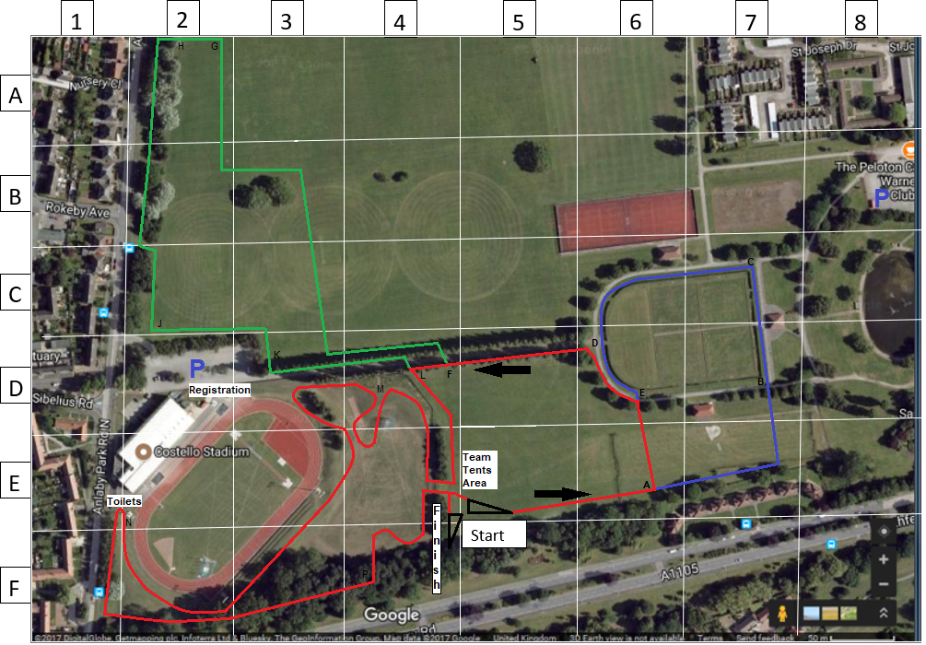

Humber Athletic Association
46th Annual Humber Cross Country Championships
(Under UKA. & E.C.C.A Rules Permit/licence No. CC21/0173
Saturday 8th January, 2022
Costello Stadium, Hull, HU4 6XQ

Approx Time | Age Group | Approx Distance | Route on Map
11:15 | Under 11 Girls | 2000m | Start – 1 medium lap – Finish  (Start-A-B-C-D-E-F-L-M-N-P-Finish)
11:15 | Under 11 Boys | 2000m | Start – 1 medium lap - Finish  (Start-A-B-C-D-E-F-L-M-N-P-Finish)
11:40 | Under 13 Girls | 3000m | Start – 1 large lap – Finish  (Start-A-B-C-D-E-F-G-H-J-K-L-M-N-P-Finish)
11:40 | Under 13 Boys | 3000m | Start – 1 large lap – Finish  (Start-A-B-C-D-E-F-G-H-J-K-L-M-N-P-Finish)
12:10 | Under 15 Boys | 5000m | Start – 1 medium + 1 large lap – Finish  (Start-A-B-C-D-E-F-L-M-N-P-A-B-C-D-  E-F-G-H-J-K-L-M-N-P-Finish)
12:10 | Under 17 Women | 5000m | Start – 1 medium + 1 large lap – Finish  (Start-A-B-C-D-E-F-L-M-N-P-A-B-C-D-  E-F-G-H-J-K-L-M-N-P-Finish)
12:30 | Under 17 Men | 6500m | Start – 1 small + 1 medium + 1 large  lap – Finish  (Start-A-E-F-L-M-N-P-A-B-C-D-E-F-L-  M-N-P-A-B-C-D-E-F-G-H-J-K-L-M-N-P  -Finish)
12:30 | Junior Women | 6500m | Start – 1 small + 1 medium + 1 large  lap – Finish  (Start-A-E-F-L-M-N-P-A-B-C-D-E-F-L-  M-N-P-A-B-C-D-E-F-G-H-J-K-L-M-N-P  -Finish)
13:05 | Under 15 Girls | 4500m | Start – 1 small + 1 large lap – Finish  (Start-A-E-F-L-M-N-P-A-B-C-D-E-F-G-  H-J-K-L-M-N-P-Finish)
13:25 | Senior Men | 12000m | Start – 4 large laps – Finish  (Start (4x) A-B-C-D-E-F-G-H-J-K-L-M-  N-P-Finish
14:05 | Junior Men | 8000m | Start – 1 medium + 2 large laps – Finish  (Start-A-B-C-D-E-F-L-M-N-P- (2x) A-B-C  D-E-F-G-H-J-K-L-M-N-P-Finish)
14:05 | Senior Women | 10000m | Start – 2 medium + 2 large laps – Finish  (Start- (2x) A-B-C-D-E-F-L-M-N-P- (2x)  A-B-C-D-E-F-G-H-J-K-L-M-N-P-Finish)
Small lap = 1000 metres Medium lap = 1400 metres Large lap = 1800 metres

www.facebook.com/groups/athletichumber www.twitter.com/athletichumber

