Fitmums & Friends
In the Pink Scheme
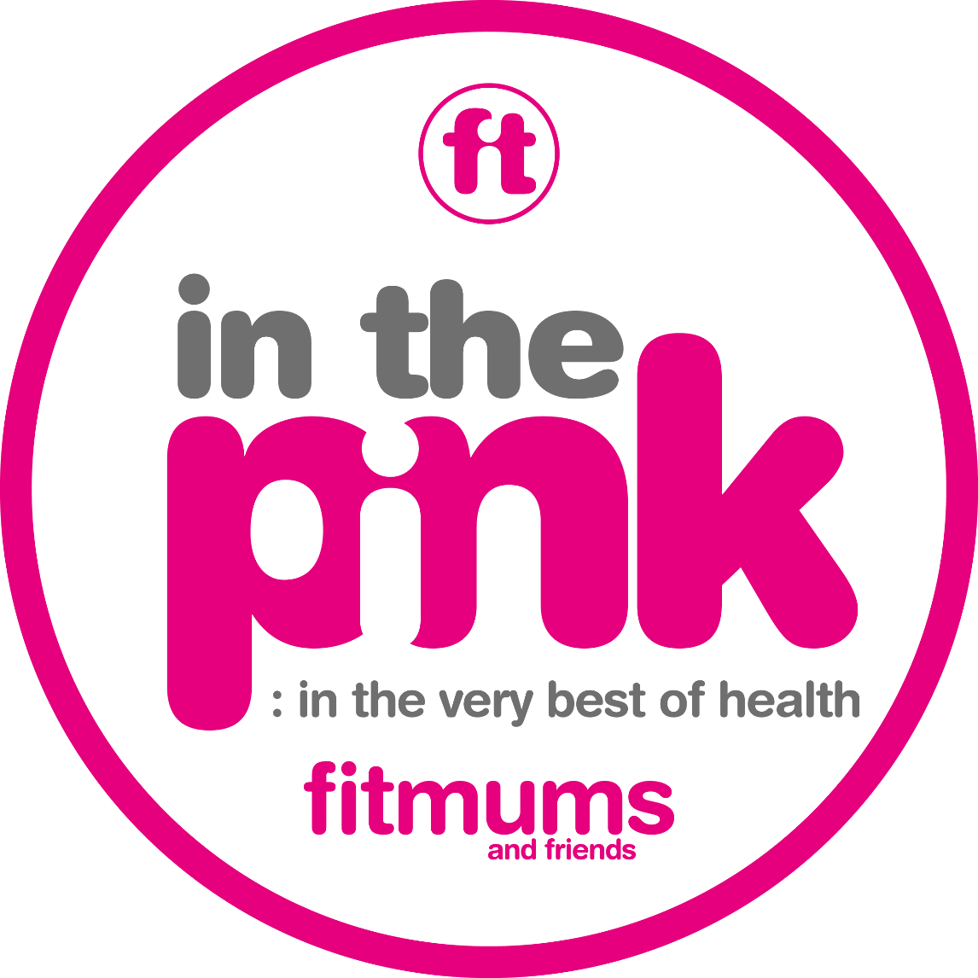
Annual Report
May 2016 – 2017
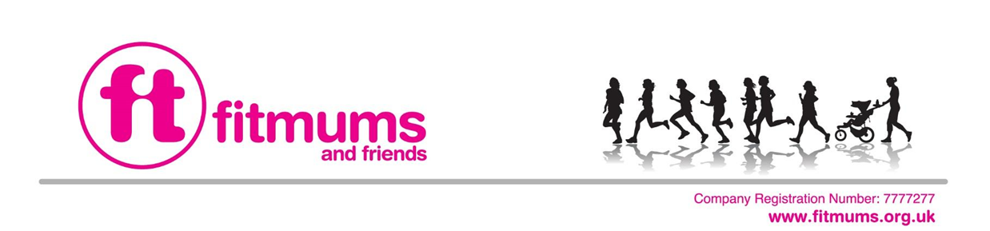
In the Pink Scheme – First year feedback
Background
In 2012, thanks to a small grant from Comic Relief (administrated by Two Ridings Community Foundation) Fitmums & Friends trialled a physical activity support scheme to help women with post-natal depression (PND) use exercise to manage the debilitating symptoms of PND. The scheme offered 1-1 support and the results of the pilot showed overwhelming improvement in health and wellbeing measured by use of validated mood questionnaires as well as by qualitative feedback. Building on the success of this model, a new scheme launched in 2016 called “In the Pink”. This scheme uses exactly the same model but has now expanded to offer 1-1 support to anyone who would benefit from a helping hand to be more active (see appendix 1).
The expansion to “In the Pink” has been possible due to grant funding from Sport England & NHS Hull CCG (Healthier Hull Community Fund). This report sets out the outcomes from the first year of operation.
The Team
The team is made up of a Co-ordinator, Clinical Psychologist and 10 Volunteer Supporters who all receive expenses for part of their commitment. They also commit a large amount of volunteer time to their roles. Administration and project support is provided by the central Fitmums & Friends team.
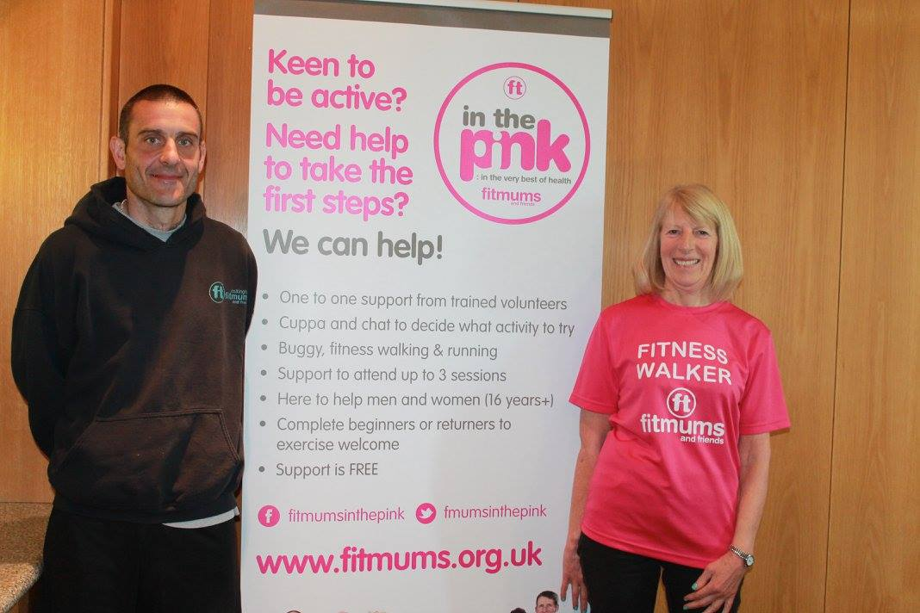

Number of referrals:
In the Pink exercise scheme launched in May 2016 and since that time has received eighteen referrals, eight of which have gone on to complete the scheme, two have declined and eight are ongoing.
Referral source:
Sixteen self-referrals, one specialist nurse referral and one Social worker referral.
Reason for referral:
Two of the referred clients were struggling with bereavement issues, two were referred with depression, five with anxiety, two with PND, two clients were recovering from illness e.g. breast cancer and four clients described low confidence as the referral problem although this was a mentioned feature with most referrals.
Postcode area: Three referrals had a Hull postcode and fifteen referrals had an East Riding postcode.

Outcome measures:
All referred clients complete a PHQ9 and GAD7 questionnaire prior to the supported exercise sessions start and again once three supported sessions have been completed.
The PHQ9 is a measure of depressive symptoms and can be repeated to monitor change over time. A score of 11+ is considered to be within the clinical range (symptoms of a moderately severe to severe depression).
The GAD7 is a measure of anxiety symptoms and can be repeated to monitor change over time. A score of 11+ is considered to be within the clinical range (symptoms of moderately severe to severe anxiety).
Both questionnaires are screening tools designed to be used as a measure of symptom presentation and are NOT diagnostic when used in isolation. Below are the pre and post scores presented in a table and bar chart format.
Table 1: Pre and Post intervention PHQ9 and GAD7 scores
Scores in the clinical range are in red.
Client ID | PHQ9 pre | PHQ9 post | GAD7 pre | GAD7 post
HMITP01 | 17 | 9 | 18 | 7
JNITP01 | 17 | 13 | 11 | 9
KPITP02 | 8 | 4 | 12 | 11
PHITP01 | 14 | 0 | 8 | 0
VMITP01 | 3 | 1 | 2 | 0
WWITP01 | 13 | 4 | 11 | 3
WWITP02 | 27 | 10 | 19 | 6
NTITP01 | 16 | 4 | 9 | 0

Chart 1: Pre and post intervention scores

Interpretation of scores:
Six of the eight clients (75%) scored within the clinical range for depressive symptoms pre intervention and five clients (62.5%) scored within the clinical range for anxiety symptoms pre intervention. All clients reported a reduction in depressive and anxiety symptoms post intervention – 87.5% reported subclinical PHQ9 and GAD7 scores post intervention. The two scores that remained within the clinical range were still a significant reduction on pre intervention score.
Have clients continued with exercise post intervention?
A further measure of the positive impact of the scheme is that if by participating in the scheme, clients feel able to incorporate regular exercise in to their lives. This is more difficult to measure without following all clients up but an initial indication of this is those clients who choose to join Fitmums & Friends as a result of taking part in the scheme. Of eight completed referrals, five (62.5%) have gone on to become members and have continued to attend sessions.
Qualitative data:
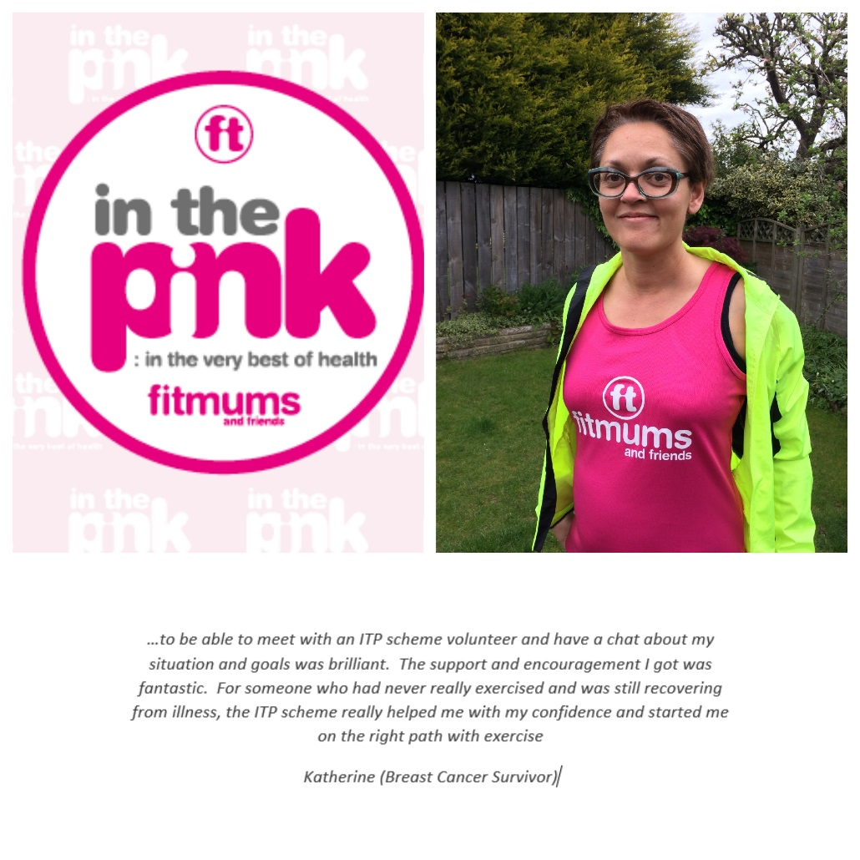
All of the participants who completed the scheme filled in a qualitative questionnaire asking them for feedback on what was helpful and the main benefits of the support they received. All were enthusiastic and rated the support they received very highly and all identified feeling happier and reported improvements in their mood as the main benefits of the supported sessions. The supportive element of the scheme was rated as highly important when asked to consider what was most useful, in particular having someone to exercise with providing the motivation and understanding that was needed at that time. Some of the positive comments included:
- “Loved it!”
- “Fantastic support team. Thank you so much!”
- “Really made a difference – I would never have come otherwise. The volunteer was supportive, encouraging, but not pushy”
- "Thank you for your help - I would never have braved it otherwise!”
- “I would not have walked through the door without it”
- “ Went home smiling”
- “Really enjoyed the support and friendly group”
- “...made me feel very good and motivated me to do more than I thought I was capable of”
- “Meeting ... and her friendly manner put me at ease – Thank you”
Promotional activity
A significant amount of promotional activity has taken place over the first year of the project.
In May, the team attended a lifestyle event at the Department of Work and Pensions as well as promote the scheme at all of the Fitmums and Friends club sessions in launch week. The team also gave a presentation at Reckitt Benckiser mental health awareness day.
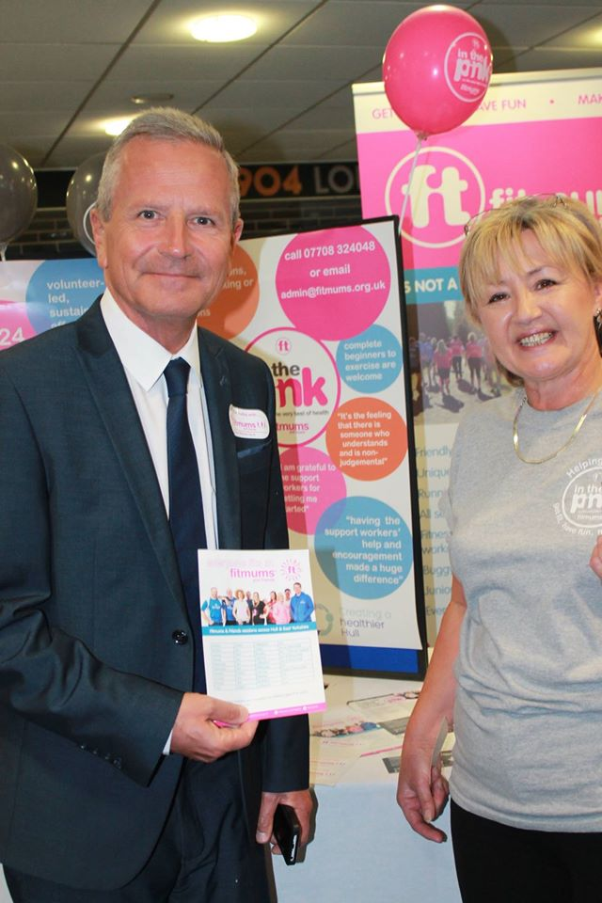
In June, the team attended a Yoga festival at the Country Park Inn, Hessle as well as attending the Hull 2020 Health Champions event in the city and promoted the scheme on the radio at West Hull FM.
During July, the team spent a day promoting the scheme at the NHS Health Expo event at the KC stadium in Hull and attended a Family Funday at Costello Stadium later the same month.
In August there was attendance at Beverley community fun day, “workout at work” events at Hull Royal Infirmary and Castle Hill Hospital and promotion at the North Hull summer fair.
During September the team have promoted at a Beverley College Freshers event and in four of the main health centres in Hull, handing out leaflets and chatting to staff and patients at the Orchard Centre, Bransholme Health Centre, Elliot Chappell Health centre and Wilberforce Health centre. The team have also made further links with the Health visitors and school nursing team in Hull and are met with the “Let’s Talk” team to consider closer links in November.
The project co-ordinator has continued to attend regular meetings with UsMums to maintain links and regularly attends the MMHAG meetings at Hull University linking the project in with other maternal mental health research and projects. There has also been attendance at other community engagement events including meeting with BME mums’ group, the Latvian community group in Hull and a parental engagement event at Cottingham Childrens’ Centre. The team were also invited to attend a two day Perinatal Mental Health conference hosted by Humber NHS Foundation Trust and team representatives attended to share information about the In the Pink scheme with perinatal mental health professionals.
It is estimated that the team has had contact with over 2000 (approx) members of the public at the various promotional and engagement events and have had one to one discussions with at least 10% of this figure (118 people approx) regarding the benefits of exercise and increasing activity.
Next steps
This first year has proved that the model of offering a hand-hold to exercise is effective for people who would not otherwise engage in physical activity. It is a very simple and cost effective means of increasing participation of vulnerable and often hard to reach people. By supporting people into groups that are highly supportive and motivational it improves the chances of the initial introduction to exercise being sustained in the long term.
The frustrating aspect of this first year are the lack of referrals, this despite an enormous amount of time and effort promoting the availability of support by the scheme. It is hoped that the launch of the new Social Prescribing service may help direct more people to In the Pink.
It is a priority to find further funding so we can continue the work undertaken by Fitmums & Friends including the In the Pink Scheme. The model, developed by Fitmums & Friends, is highly sustainable since it uses a predominantly volunteer workforce with expert set-up and ongoing management. We need to attract longer term investment and ensure potential funders see us as credible providers of a high quality and effective service. We would also like to extend the reach of In the Pink support to our increasing Fitmums & Friends footprint now extending out of the Humber (Grimsby, Dearne Valley & Harrogate).

Report completed by
Dr Nicola Green, Clinical Psychologist
Samantha Barlow BEM – Chief Officer (Fitmums & Friends)
June 2017

Appendix 1

