Boothferry Fitmums Running Routes
Route 9 – HFRS Base

L Summergroves, cross road, R Hessle Rd, L Graham Ave first road on the right follow then 2nd road, L Graham Ave, R Hessle Rd cross road, L Summergroves  BoothFM - Route 9; 1 mile. Mapometer.com running route #5506719 | 1 mile
L Summergroves, L Hessle Rd, L Priory Way cross onto Sainsbury Way onto Green Lane onto Windmill Way, R Itlings Lane, L Hull Rd round to Square round to Southgate, R Swinegate onto Eastgate, L Hull Rd onto Hessle Rd, R Summergroves HQ  BoothFM - Route 9; 2 miles. Mapometer.com running route #5506720 | 2 miles
L Summergroves, L Hessle Rd onto Hull Rd, R Northolme Rd, R Beverley Rd, R Boothferry Rd, R First Lane, L Hull Rd onto Hessle Rd, R Summergroves HQ  BoothFM - Route 9; 3 miles.. Mapometer.com running route #5506721 | 3 miles
L Summegroves, R Hessle Rd cross road, L Pickering Rd, L Boothferry Rd, R APRN, R Park Lane West, R The Link, R Park Road East through snicket near end, R Pickering Rd cross roundabout straight on Pickering Rd, R Hessle Rd, L Summergroves HQ  BoothFM - Route 9; 4 miles.. Mapometer.com running route #5506723 | 4 miles
L Summergroves, R Hessle Rd cross road, L Pickering Rd cross & continue on Pickering Rd, L St Joseph Drive follow round to R to Lexington Drive (do not take the 1st right on Lexington), L Pickering Rd, L Anlaby Rd, L Plantation Drive West, R Mead Walk, L Coppice Side, R Park Rd West, L Holme Close, L Southern Drive, L Woodland End, R Plantation Dr West, R Anlaby Rd, R Belgrave Dr, L Eastfield cross to Sunbeam Rd, L Pickering Rd cross roundabout onto Pickering Rd, R Hessle Rd, L Summergroves HQ  BoothFM - Route 9; 5 miles.. Mapometer.com running route #5506725 | 5 miles
L Summergroves, L Hessle Rd onto Hull Rd, R First Lane, L Seaton Rd onto Richmond Rd, L Beverley Rd, L Northholme Rd, R Hull Rd, L Buttfield Rd, R Bon Accord Rd, R Station Rd, R Chestnut Ave, L Davenport Ave, R Heads Lane, R Tranby Ave, L Barrow Lane, R Swanland Rd, L Beverley Rd, R Boothferry Rd, R First Lane, L Hull Rd onto Hessle Rd, R Summergroves to HQ  BoothFM - Route 9; 6 miles... Mapometer.com running route #5506727 | 6 miles

ROUTE 9
1 | 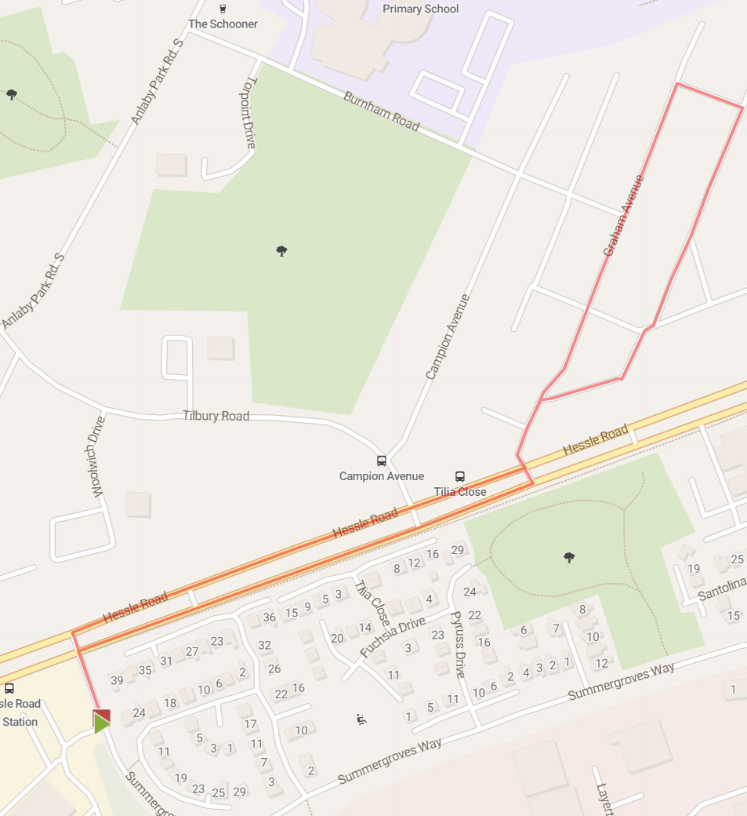
2 | 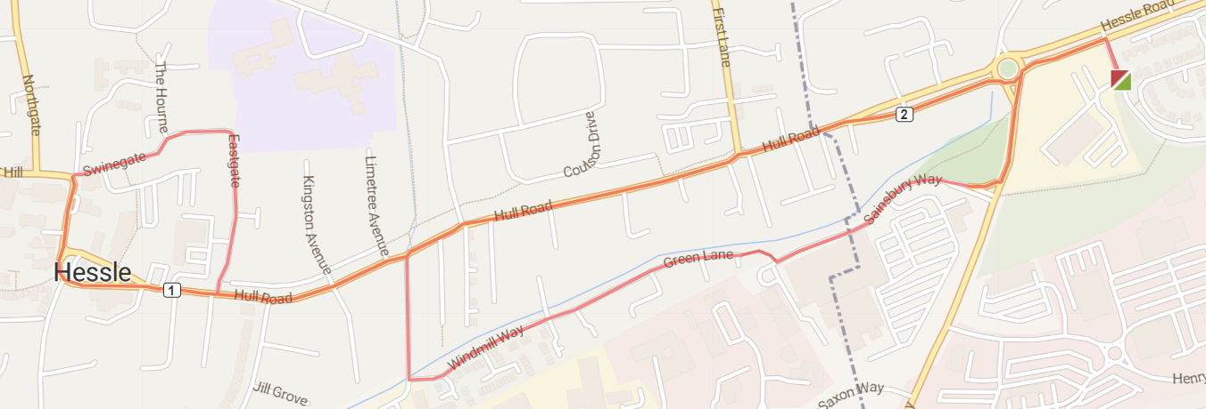
3 | 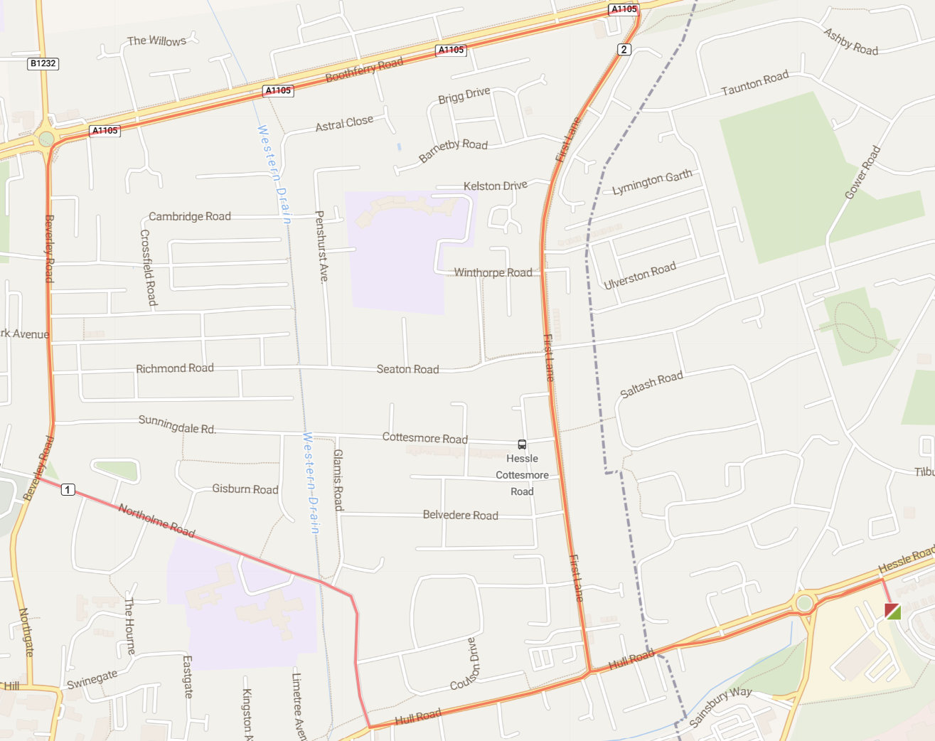
4 | 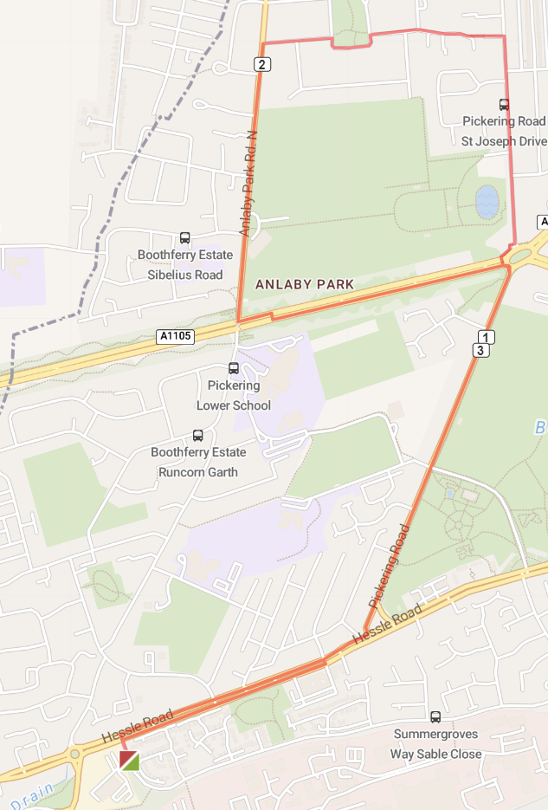
5 | 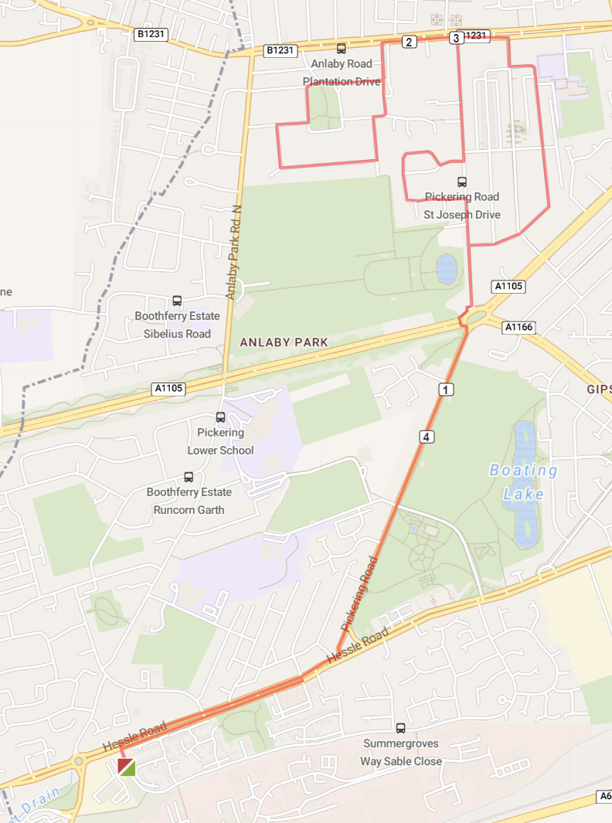
6 | 