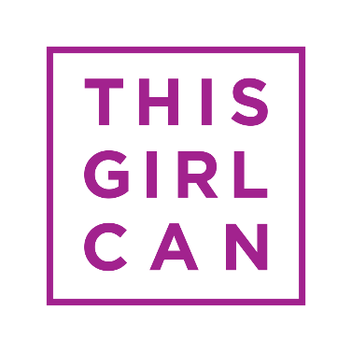
THIS GIRL CAN CASE STUDY FORM

Your story can inspire others
This Girl Can is a celebration of active women who are doing their thing no matter how well they do it, how they look or even how red their face gets.
We think your story is one that can inspire more women to get active. Your story may be used on our website and social media channels, and may be used in newspapers, publications, radio or TV.
We will talk to you about the ways in which we would like to use your story and you can let us know what you’re comfortable with.
If at any time in the future, you no longer want to have your story told, that’s fine. Please email thisgirlcan@sportengland.org and we will not use it again.
Please fill in the questionnaire below and submit it with a head and shoulders photo of yourself and a few landscape images of you taking part in your activity/activities.
Finally, we want to say a huge thank you for allowing us to share your story and for helping to encourage more women to get active.
The This Girl Can Team.

Case Study Questionnaire
Name
Age*
Date of birth
Nationality
Ethnicity
Occupation
Home town
Phone number(s)**
Email address**
Twitter handle***
Instagram handle***
Blog or any other relevant links
Do you have any children?
If so, how many?
Can you provide a short summary of the barriers that stopped you from getting active?
Can you provide a short summary of what motivated you to get
Can you provide a short summary of how you fit exercise into your routine, and juggle it with other commitments?

Please send completed This Girl Can case study forms to thisgirlcan@sportengland.org

* If under the age of 18, does your parent or guardian give permission for your story to be shared?
**The media may want to contact you to interview you, but your contact details will not be given to them without your permission.
*** You only need to share these with us if you’re using these channels and would be happy for us to tag you on social media when sharing your story.

Data Protection
We will only use the information you have provided to produce media case studies which promote the benefits of sport and physical activity. We will not share your data with any third parties without your prior consent. Your data will be held securely and will only be kept for as long as it remains relevant to our work. Our full Privacy and Data Protection Statement is published on our website at http://www.thisgirlcan.co.uk/terms-conditions/

