MARKET WEIGHTON 6 Mile routes

ROUTE A https://gb.mapometer.com/running/route_5253740
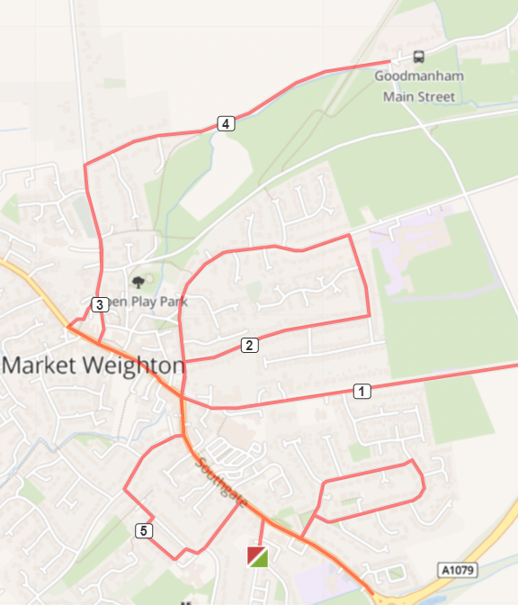
Base - L onto Southgate -Cross zebra crossing continue - At Roundabout R onto Beverley
Rd – Hazard: Use LHS for path - Run up to Humber Street, Yorkshire Water Works - turn
around and back Beverley Rd -At Roundabout R Finkle Street - continue to Spring Rd
– Hazard: High kerb drop from path to road - R onto Hill Rise, R onto Hill Rise - L onto
Finkle Street - R onto High Street - R into car park (Metal Archway) run across – Hazard:
Caution needed - L crossover and onto Londesborough Road - R onto Goodmanham Rd
(RHS on path) run to Red Lane - Turn and return on G’manham Road (LHS) – Hazard: No
path under railway bridge) - L onto Londesborough Rd - L Market Place, cross zebra
crossing (Topaz) - L continue on Market Place - onto High Street - T/R onto Southgate -
T/L onto Hawling Road - L Princess Road - Princess Close (No entry signs) - R Princess
Road – Hazard: Run on grass and rejoin path - R onto Southgate - continue straight onto
Sancton Road. Cross zebra crossing (continue R on Sancton Road) - L Langdale Road - R
Bedale Road - L onto Wold Avenue - L onto Langdale Road - L onto Sancton Road run to
roundabout. Return back on Sancton Road, cross crossing and R to base

Cautions in red

ROUTE B https://gb.mapometer.com/running/route_5259490

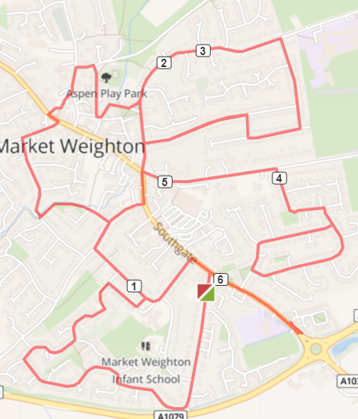
R onto Cliffe Rd - R onto Shipman Rd -At end of Shipman Road, take the cut through R
onto Princess Cl - L Princess Rd - R Hawling Rd - L Southgate -At Roundabout straight across
onto Finkle Street and crossover to run on RHS -Continue onto Spring Rd – Hazard: High
kerb drop from path to road - R Hill Rise - Hill Rise Close - R Hill Rise Drive - R onto Hill Rise
Drive - L onto Hill Rise - R Finkle St and repeat loop – Spring Road, R Hill Rise, Straight onto
Hill Rise Close, R Hill Rise Dr, R Hill Rise Dr - R onto Finkle Street - L at The Green, War
Memorial Institute (take left turn next to building) - R onto St Helen’s Square – Hazard:
Use LHS to remain on narrow foothpath - R onto Church Cl and R onto Station Road - L
onto Hall Road - L Londesborough, crossover and R through car park – Hazard: Caution
needed - L Market Place - R Holme Road – use LHS - L Glenfield Ave to bottom – Hazard:
Bike Gate - L alongside Weighton Beck and onto Scotts Croft - L onto Hawling Rd - L
Southgate - At Roundabout R onto Beverley Rd (keep RHS) - R Lysander Drive - R Bedale Rd
- L Wold Ave - L Langdale Rd - L Bedale Rd - L onto Lysander Ave - L onto Beverley Rd - At
Roundabout cross over L onto Southgate - R Hawling Rd - L Princess Rd - R Southgate -
Continue straight onto Sancton Rd up to entrance of St Mary’s RC School and return back
on Sancton Rd - L into Cliffe Rd and base

Cautions in red

ROUTE C SUMMER https://gb.mapometer.com/running/route_5259495

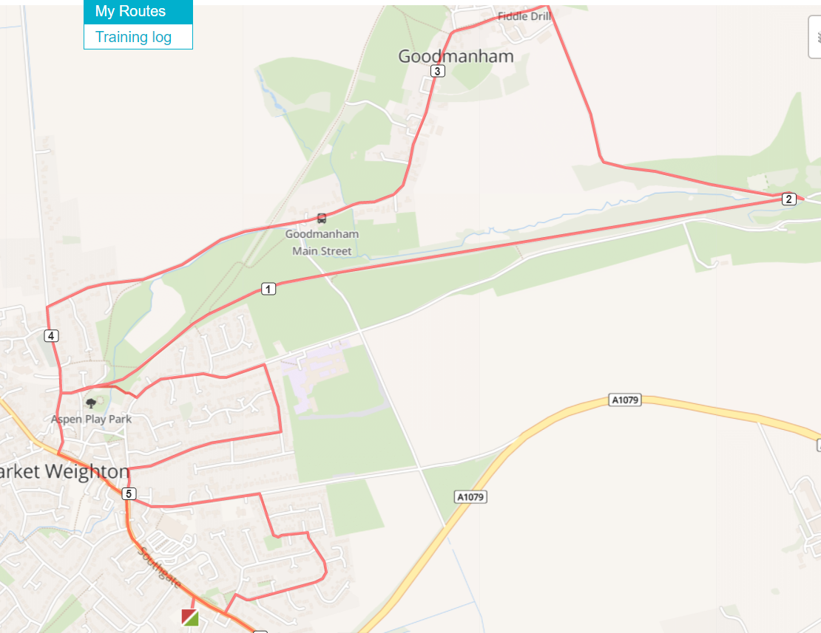
Base – L onto Southgate – At Roundabout L onto High Street – Continue
onto Market Place Use zebra crossing at Topaz – R onto Londesborough Road – R onto Hall Road – Join Hudson Way Track uneven surface – L at gate onto Yorkshire Wolds Way to Goodmanham Country Road with no path – L onto Main Street Alternate between sides for paths through. Goodmanham – L onto Goodmanham Road at pub High kerb drop –
Under railway bridge No path, use LHS – L onto Londesborough Road – L
onto Hall Road – At fork, take R path alongside park Bike gate – L onto
Spring Road High kerb drop – R onto Hill Rise – R onto Hill Rise – L onto
Finkle Street – Cross Roundabout and L onto Beverley Rd – R onto
Lysander Dr – R onto Bedale Rd – L onto Langdale Rd – L onto
Sancton Rd up to Kings Ct and return back on Sancton Rd, Use
crossing – R onto Sancton Road – L onto Cliffe Road - Base

Cautions in red

ROUTE D https://gb.mapometer.com/running/route_5253744

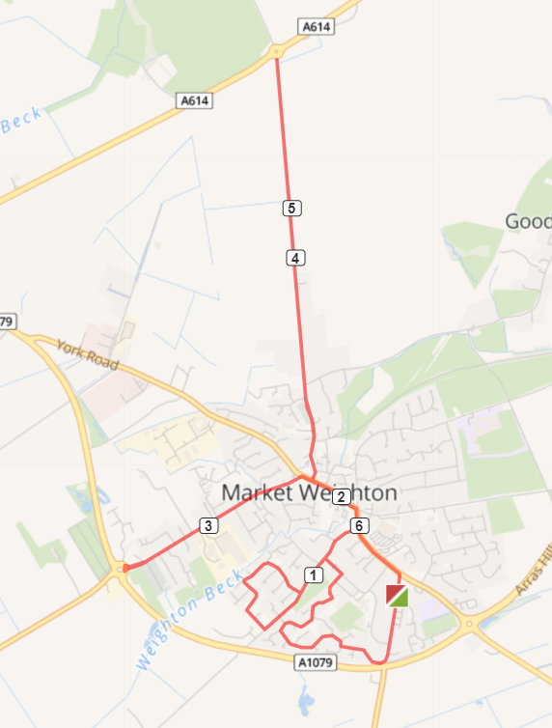
Base – R onto Cliffe Road – R onto Shipman Road – At the end of Shipman Rd, take the cut through onto Princess Close – L onto Princess Road – L onto Hawling Rd – Continue on Hawling Rd Use RHS – R onto Wicstun Way and follow all the way round – L onto Hawling Road – L onto Southgate – At Roundabout L onto High Street – Continue onto Market
Place – L onto Holme Road up to Roundabout – Return back on Holme Rd – R onto Market Place – L onto Londesborough Road up to Roundabout Use RHS - Return Londesborough Road – L onto MarketPlace Use Zebra Crossing at Topaz – Continue onto High Street – R onto Southgate – R onto Cliffe Road - Base

Cautions in red

ROUTE E https://gb.mapometer.com/running/route_5277369

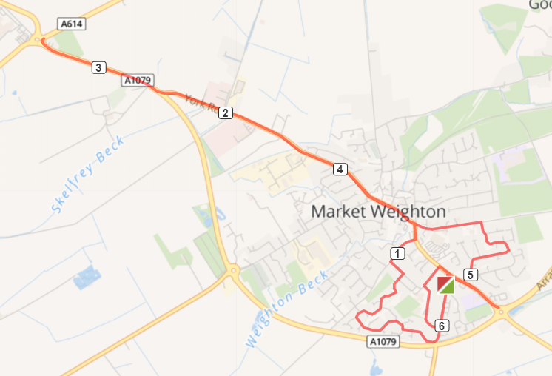

Turn R out of base onto Cliffe Rd
R Shipman Rd at the end of Shipman Rd take the cut through onto Princess cl, L Princess Rd - R Hawling Rd - L Southgate - L at roundabout onto High St, continue onto market place - continue onto York Rd - continue to roundabout . Return back to Beverley Rd. R Lysander Dr. R Beadale Rd, L Landale Rd. L onto Sancton rd continue to Roundabout, return back, (southgate) L princess rd, L princess Rd, L Cliff Rd back to base.

Cautions: Uneven surfaces, use crossings to cross roads.

ROUTE F - MW FM 6 Mile Route F . Mapometer.com running route #5396065
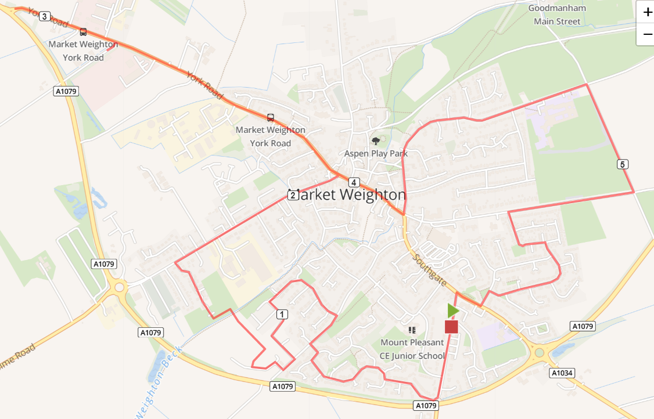

Turn R out of base onto Cliffe Rd, to end bear R Shipman Rd. At T-Junction/ road divide R continue Shipman Rd, T-junction R then L take the snicket pathway through to Sweep Rd (caution bollards, low light) R on Sweep Rd, L onto Wicstun Way. Follow Wicstun Way keeping L until turns in Butler Drive, R Sweep Rd, to end R Ombler Drive, 1st R Beales Close over Weighton Beck, L Coperland Crescent, R Sandholme to end R Holme Rd. At end Holme Rd, cross road L on York Rd continue to roundabout (caution path, light) RETURN York Rd, Market Place, High St, mini roundabout L Finkle St, follow up Spring Rd, R Humber St / the old roman rd by Berties Field (caution uneven, low light), R down Beverley Rd, L onto Lysander Dr, R Bedale Rd, L onto Langdale, R onto Sancton Rd, cross zebra crossing L onto Cliffe Rd back to base
Cautions – bollards, narrow path low light snicket from Shipman to Sweep Lane, uneven pavements along the route, new road surface areas with high kerbs, low light (Beales Close area), narrow path, no light after Becklands Ind est. Road crossings, uneven no light Humber St old roman rd.

.

