Boothferry Fitmums Running Routes
Route 6 – HFRS Base

 | 1 mile
Exit base, L onto Hessle Rd, onto Hull Rd, caution use care crossing road, R onto First Lane, L Belvedere Rd, R Glamis Rd, L Sunningdale Rd, R Beverley Rd, R Richmond Rd, onto Seaton Rd, R First Lane, L Hull Rd, onto Hessle Rd, and back to base caution crossing road  BoothFM - Route 6; 2 miles. Mapometer.com running route #5499739 | 2 miles
Exit base, L onto Hessle Rd, onto Hull Rd, caution use care crossing road, R onto First Lane, L Belvedere Rd, R Glamis Rd, L Sunningdale Rd, R Beverley Rd, R Richmond Rd, L Penshurst Ave, L Cambridge Rd, R Astral Rd, through snicket onto Boothferry Rd, turn R, R First Lane, L Hull Rd, onto Hessle Rd, and back to base caution crossing road  BoothFM - Route 6; 3 miles. Mapometer.com running route #5499761 | 3 miles
Exit base, L onto Hessle Rd, onto Hull Rd, caution use care crossing road, R onto Northolme Rd, onto Swanland Rd, L Mount Ave, L Barrow Lane, cross road, R Tranby Ave, R Heads Lane, R Boothferry Rd, straight on at Darleys roundabout, R snicket opposite pedestrian crossing, onto Astral Rd, L Cambridge Rd, R Penshurst Rd, L Seaton Ave, R First Lane, R Cottesmore Rd, L Glamis Rd, L Belvedere Rd, R First Lane, L Hull Rd, onto Hessle Rd, and back to base caution crossing road  BoothFM - Route 6; 4 miles. Mapometer.com running route #5499738 | 4 miles
Exit base, L onto Hessle Rd, onto Hull Rd, caution use care crossing road, straight onto Hessle Sq, R Southgate, L Swinegate, R Northgate, L Trinity Grove, R Brunswick Grove, L Westbourne Gr, R Barrow Lane, L Swanland Rd, R Boothferry Rd, caution cross with care, L Holly Drive, R Holly Drive, L Cherry Ave and round back to Holly Drive, L Boothferry Rd, caution use flyover, R snicket onto Astral Rd, L Cambridge Rd, R Penshurst Rd, L Seaton Rd, R First Lane, R Cottesmore Rd, L Glamis Rd, L Northolme Rd, R Hull Rd, L Itlings Lane, L Windmill Way onto Green Lane and Sainsbury Way, L Priory Way, R Hessle Rd, and back to base caution crossing road  BoothFM - Route 6; 5 mile. Mapometer.com running route #5499737 | 5 miles
Exit base, L onto Hessle Rd, onto Hull Rd, caution use care crossing road, straight onto Hessle Sq, up Prestongate, L The Weir, R Ferriby Rd, R Heads Lane, R Tranby Ave, L Barrow Lane, L Swanland Rd, R Boothferry Rd, R snicket onto Astral Rd, R Cambridge Rd, L Crossfield Rd, L Northfield Ave, R Hillman Rd, L Richmond Rd onto Seaton Rd, R First Lane, R Cottesmore Rd, onto Sunningdale Rd, L Beverley Rd, L Northolme Rd, R Hull Rd, L Itlings Lane, L Windmill Way onto Green Lane and Sainsbury Way, L Priory Way, R Hessle Rd, and back to base caution crossing road  BoothFM - Route 6; 6miles. Mapometer.com running route #5499736 | 6 miles

ROUTE 6
1
2 | 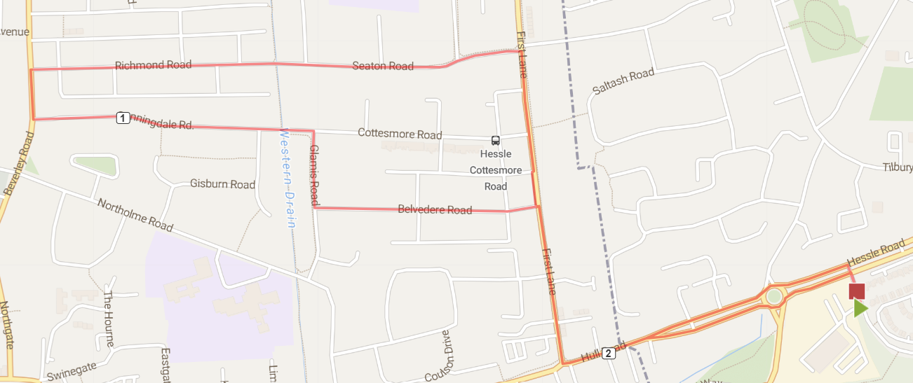
3 | 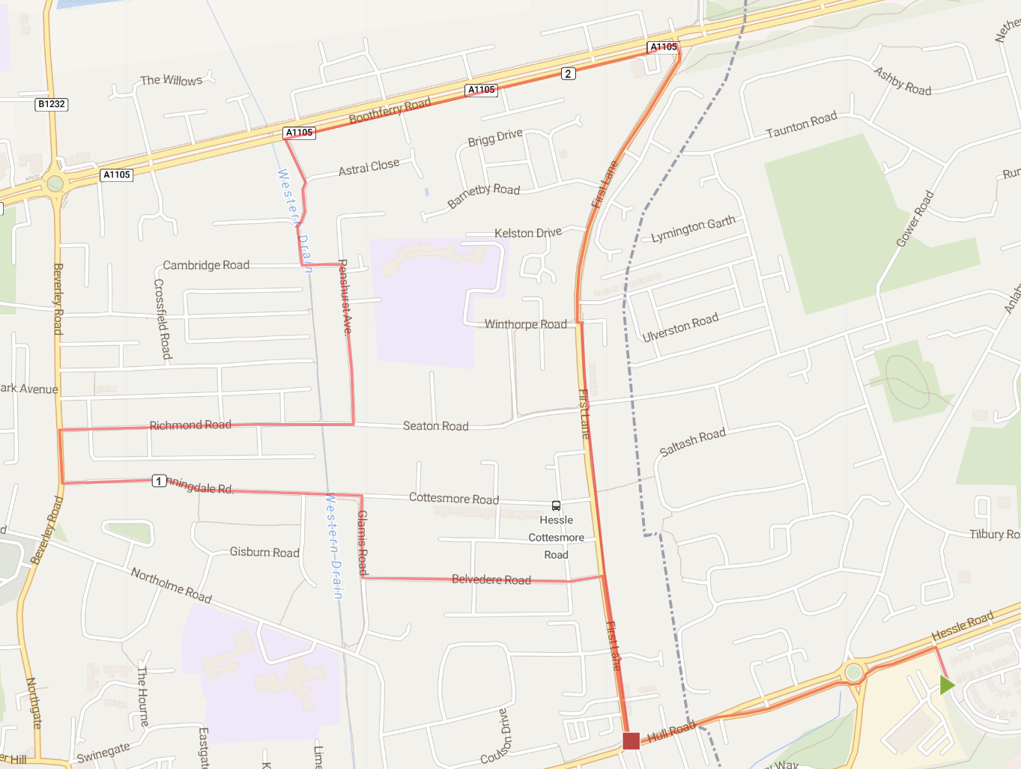
4 | 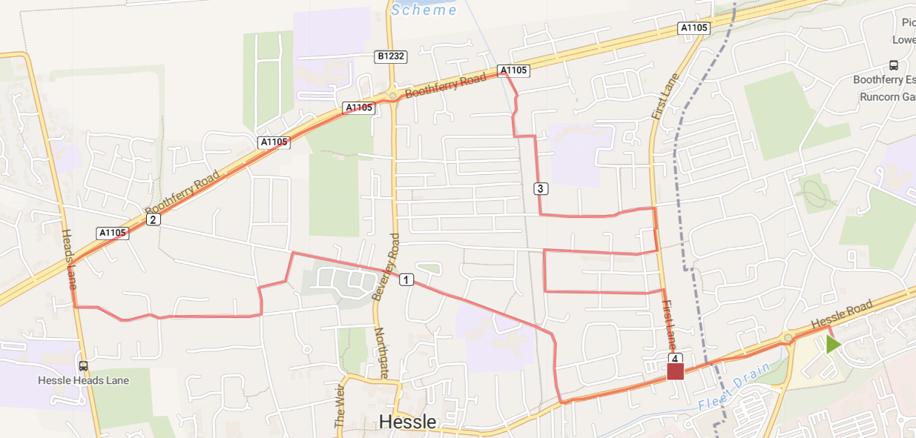
5 | 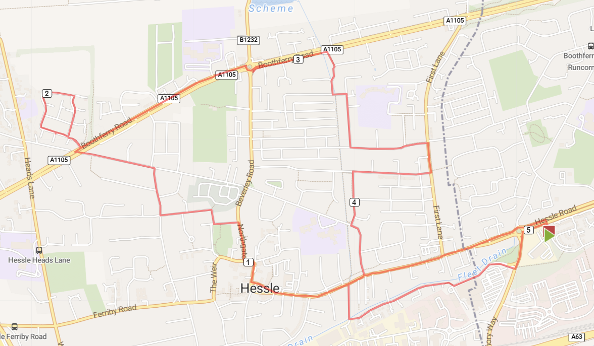
6 | 