National Walking Month – May 2018
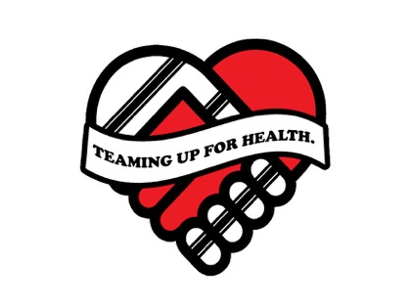
Teaming up for Health Walking Challenge
The Teaming up for health partnership are inviting fans of the Rugby League Clubs and Hull 2020 Health Champions to complete and log walking during May which is National Walking Month.
Each time you walk for at least 20 minutes, where you can talk but not sing, please give yourself a tick on the calendar below.
At the end of the month please return by Wednesday 6th June 2018. After this date the winning team will be announced.
Hull KR | Hull FC | 2020 Health Champions
Lizzie.Borrill@hullkr.co.uk | Olivia.Jackson@hullfc.com | Emma.Kelly25@nhs.net  Christine.ebeltoft@nhs.net
Community Trust  KCOM Craven Park  Poorhouse Lane  Hull HU9 5HE | Community Foundation  The KC Stadium  West Park  Hull HU3 6HU | NHS Hull CCG  2nd Floor, Wilberforce Court  Alfred Gelder Street  Hull HU1 1UY

Please utilise the following in social media #hullthy, teaming up for health, @hullkrofficial, @HullChampions, @hullfcofficial, @NHSHullCCG and @hullccnews.
Fitmums & Friends, member name:
Tues 1st |  | Thur 17th
Wed 2nd |  | Fri 18th
Thur 3rd |  | Sat 19th
Fri 4th |  | Sun 20th
Sat 5th |  | Mon 21th
Sun 6th |  | Tues 22nd
Mon 7th |  | Wed 23rd
Tues 8th |  | Thur 24th
Wed 9th |  | Fri 25th
Thur 10th |  | Sat 26th
Fri 11th |  | Sun 27th
Sat 12th |  | Mon 28th
Sun 13th |  | Tue 29th
Mon 14th |  | Wed 30th
Tue 15th |  | Thur 31st
Wed 16th

More information about National Walking Month, run by Living Streets, can be seen https://www.livingstreets.org.uk/what-you-can-do/campaigns/national-walking-month-2018.

