Boothferry Fitmums Running Routes
Route 10 – HFRS Base

HQ cross road, R Summergroves, L Robinia Drive, L Santolina Way, R Summergroves to HQ  BoothFM - Route 10; 1 mile. Mapometer.com running route #5506730 | 1 mile
L Summergroves, L Hessle Rd onto Hull Rd onto The Square, L Southgate, L Station Rd/Ferry Road, L Buttfield Rd, R Hull Rd onto Hessle Rd, R Summergroves HQ  BoothFM - Route 10; 2 miles. Mapometer.com running route #5506732 | 2 miles
L Summergroves, L Hessle Rd, cross to Sainsbury Way, down Green Lane, onto Windmill Way, R onto Itlings Lane, L Hull Rd, L Buttfield Rd, to Ferry Rd, L Castle Way, R Danes Rd, R Vaughan Rd, R Station Rd, L Chestnut Ave, L Ferriby Rd, R Barrow Lane, R Sailsbury St, R The Weir, L Prestongate cross onto Hull Rd onto Hessle Rd, R Summergroves HQ  BoothFM - Route 10; 3 miles. Mapometer.com running route #5506735 | 3 miles
L Summergroves onto Hull Rd, R First Lane, L Winthorpe Rd, L Seagran Ave, R Seaton Rd, becomes Richmond Rd, L Beverley Rd, L Northholme Rd, R Hull Rd, L Buttfield Rd, R Ferry Rd becomes Station Rd, R South Lane, L Ferriby Rd, R Barrow Lane, R Sailsbury St, R The Weir, L Prestongate, R Hull Rd onto Hessle Rd, R Summergroves HQ  BoothFM - Route 10; 4 miles. Mapometer.com running route #5506736 | 4 miles
L Summergroves cross Hessle Rd, R Hessle Rd, L Pickering Road, L Boothferry Rd cross road bridge straight down APRN, R Park Lane West, R Holme Close, L Southern Drive, L Woodland End, R Plantation Drive, R Anlaby Road, R Pickering Road cross roundabout continue on Pickering Rd, L Hessle Road cross road, R Summergroves to HQ  BoothFM - Route 10; 5 miles.. Mapometer.com running route #5506738 | 5 miles
R Summergroves cross Hessle Rd, L Hessle Rd, R Pickering Rd cross roundabout, R Boothferry Rd, L Belgrave Drive, R Eastfield Rd, R Belgrave Drive, L Anlaby Rd, L APRN, L Mead Walk, R Coppice Side, R Park Lane West, L Holme Close, L Southern Drive, L Woodland End, R Plantation Dr W, R Anlaby Rd, R Pickering Rd cross roundabout continue onto Pickering Rd, R Hessle Rd cross road L Summergrove to HQ  BoothFM - Route 10; 6 miles.. Mapometer.com running route #5506741 | 6 miles

ROUTE 10
1 | 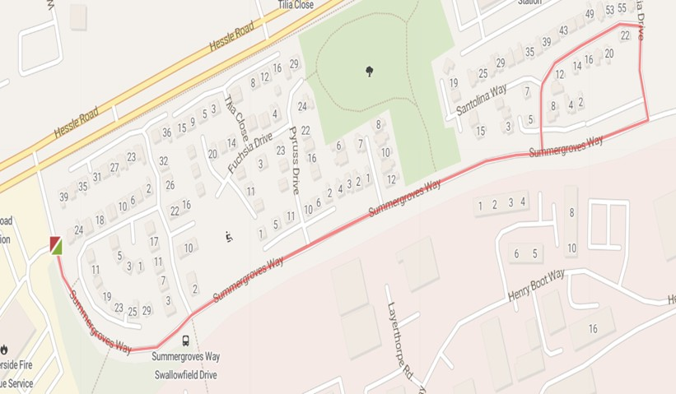
2 | 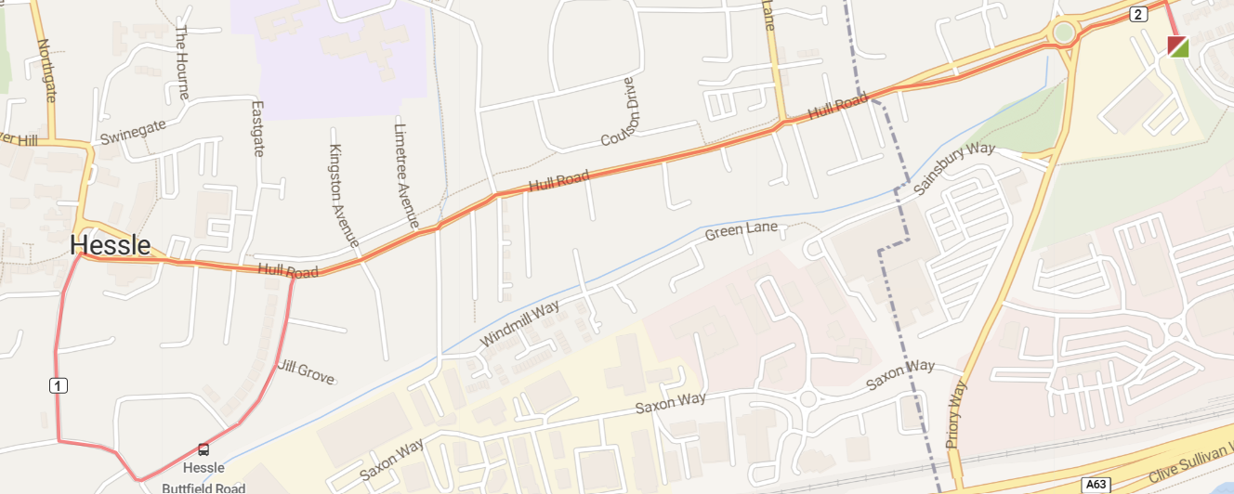
3 | 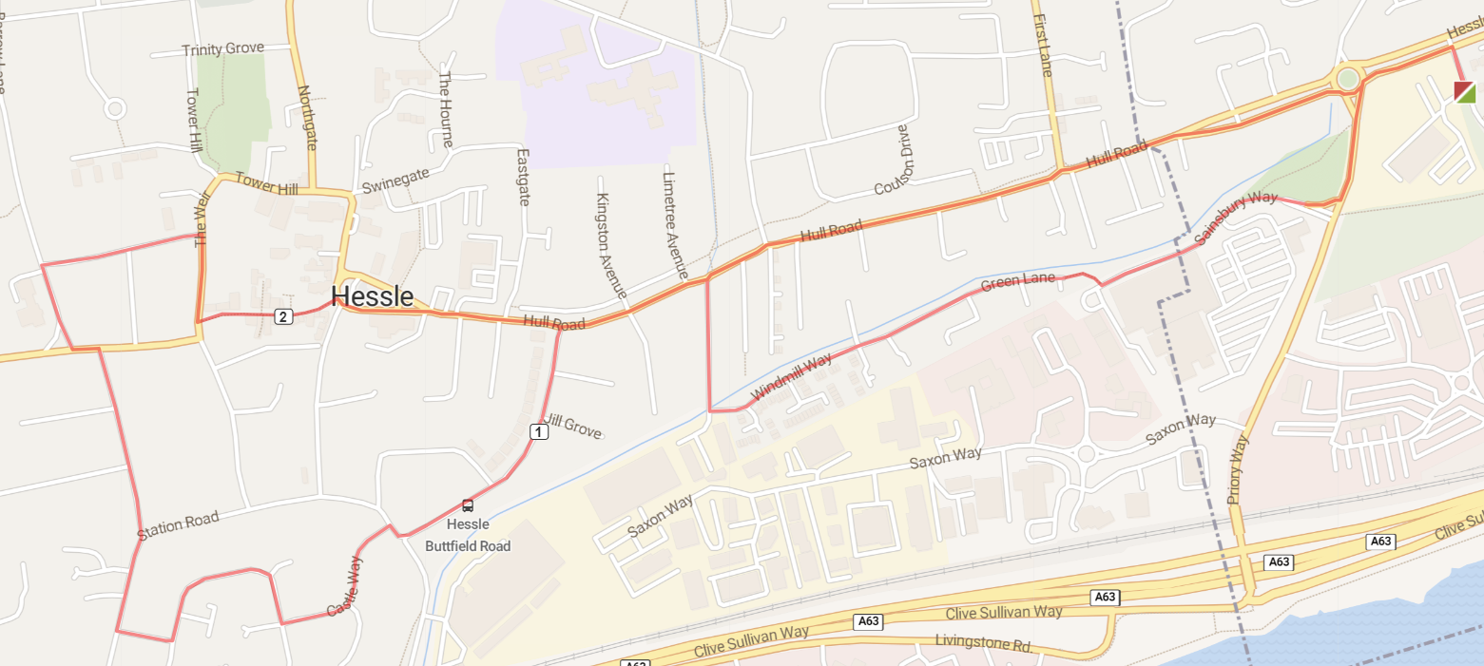
4 | 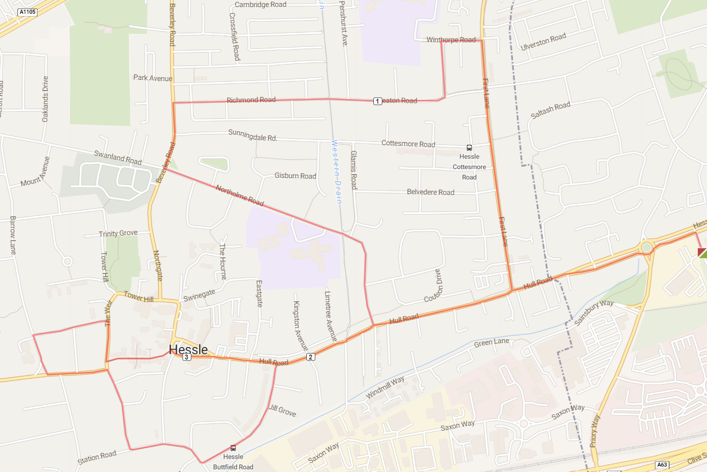
5 | 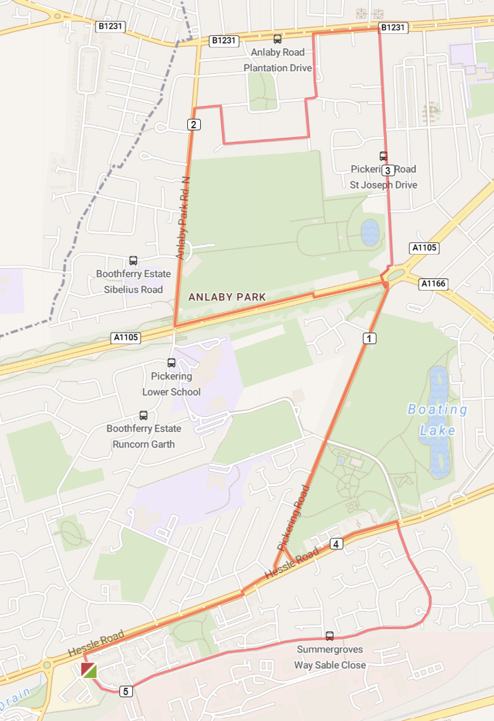
6 | 