Boothferry Fitmums Running Routes
Route 3A (Reverse) – HFRS Base

Exit base and turn L onto Hessle Rd, L Priory Way, Caution: use crossing, R Sainsburys Way, onto Green Lane, Windmill Way, R Itlings Lane, R Hull Rd, onto Hessle Rd and back to base. Caution when crossing road.  BoothFM - Route 3A; 1 mile. Mapometer.com running route #5506554 | 1 mile
Exit base, turn L onto Hessle Rd, L Priory Way, caution when crossing road, R onto Sainsbury Way, onto Green Lane, onto Windmill Way, R Itlings Lane, L Hull Rd, L Buttfield Rd, R Ferry Rd, onto Station Rd, R South Lane onto The Weir, R Prestongate, Hessle Sq onto Hull Rd, onto Hessle Rd and back to base. Caution when crossing road.  BoothFM - Route 3A; 2 miles. Mapometer.com running route #5506556 | 2 miles
Exit base, L Hessle Rd, onto Hull Rd, R First Lane, caution: use crossing, L Belvedere Rd, L Glamis Rd, R Northolme, cross road onto cycle path, cross Hull Rd onto Itlings Lane, L Windmill Way, onto Green Lane, onto Sainsburys Way, R Priory Way, caution: use crossing L Henry Boot Way , 2nd exit at roundabout, R at next roundabout, L at snicket, L Summergroves Way back to base.  BoothFM - Route 3A; 3 miles. Mapometer.com running route #5506558 | 3 miles
Exit base, L Hessle Rd, caution cross with care, R First Lane, L Seaton Rd, R Penshurst Ave, L Cambridge St, R Astral Rd, onto Astral Close, L snicket, L Boothferry Rd, L Beverley Rd, L Northolme Rd, L Hull Rd, onto Hessle Rd, R Priory Way. Caution use crossing. L Henry Boot Way, 2nd exit at roundabout, bear right at next roundabout, L snicket, Summergroves Way, back to base.  BoothFM - Route 3A; 4 miles. Mapometer.com running route #5506559 | 4 miles
Exit base, R Hessle Rd caution cross with care, L Graham Ave, L Burnham Rd, L Campion Ave, R Tilbury Rd, R APRS, L Bethune Ave, L First Lane, R Cottesmore Rd, onto Sunningdale Rd, L Gisburn Rd, R Gisburn, L Gisburn Rd, R Northolme Rd, onto Swanland Rd, L Barrow Lane, L Westbourne Grove, R Brunswick Grove, R Trinity Grove, L Tower Hill, onto Swinegate, R Southgate, L Hessle Sq, onto Hull Rd, onto Hessle Rd, caution: use crossing, R Priory Way, caution use crossing L Henry Boot Way, 2nd exit at roundabout, R at next roundabout, L snicket, L Summergroves Way and back to base.  BoothFM - Route 3A; 5 miles. Mapometer.com running route #5506561 | 5 miles
Exit base, L Hessle Rd caution cross with care, R APRS, L Tilbury Rd, R APRS, caution cross with care, onto APRN, L Sibelius Rd, R St Thomas More Rd, through snicket, R First Lane, L Hull Rd, R Wilson St, L Wolfreton Drive, L Springfield Way, L Beverley Rd, R Woodland Drive, L Croft View, L Tranby Lane, R Beverley Rd, Caution use care at roundabout, continue Beverley Rd onto Northgate, L Swinegate, R Southgate, L Hessle Square, onto Hull Rd, onto Hessle Rd and back to base.  BoothFM - Route 3A; 6 miles. Mapometer.com running route #5506562 | 6 miles

ROUTE 3A
1 | 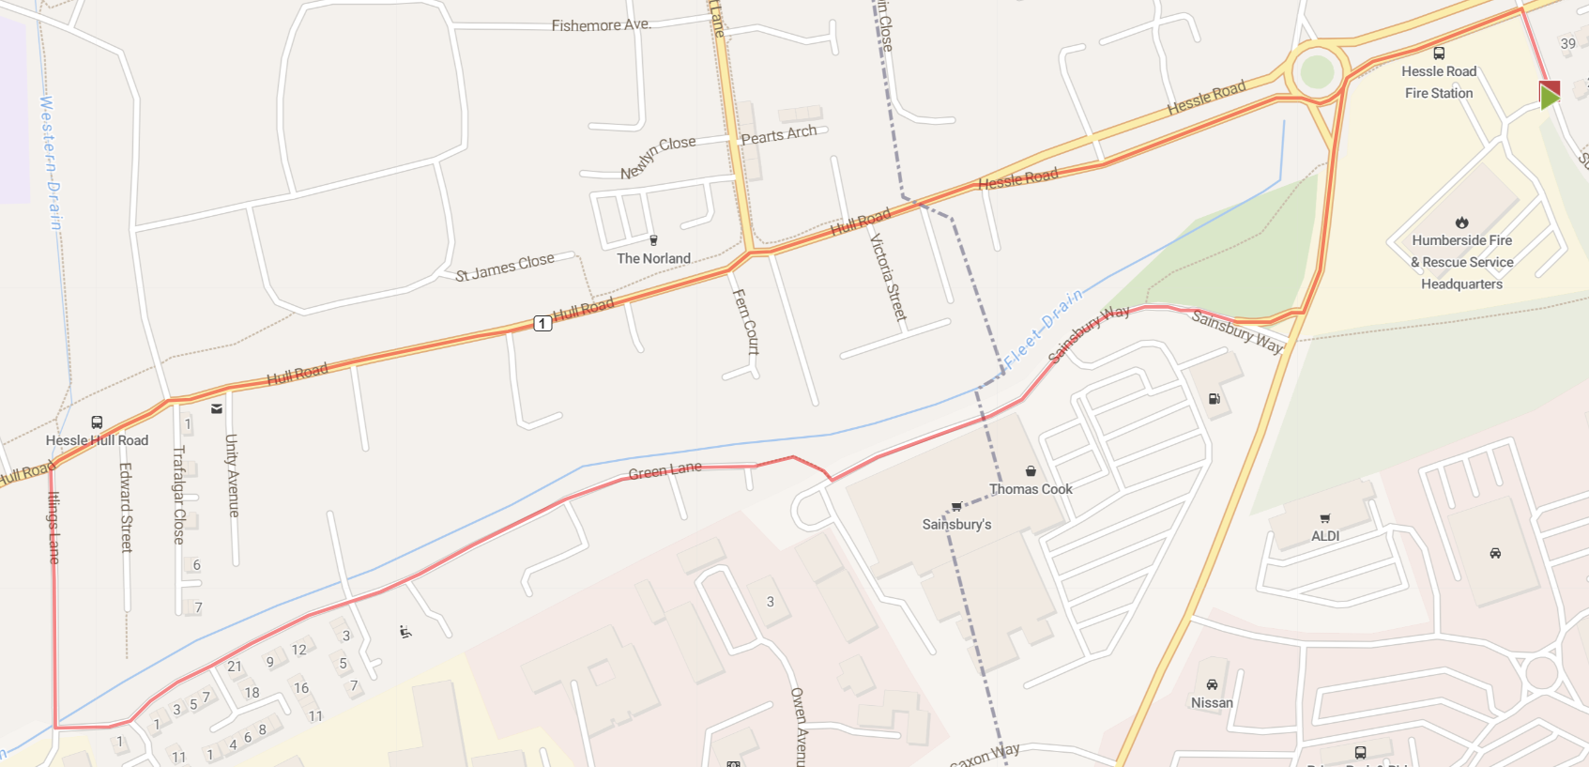
2 | 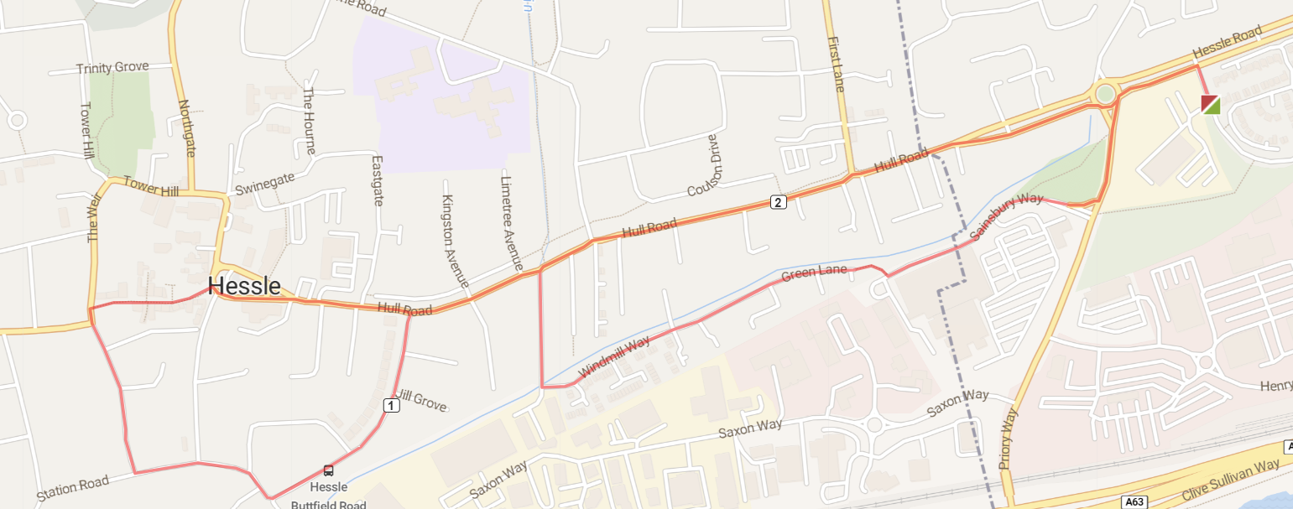
3 | 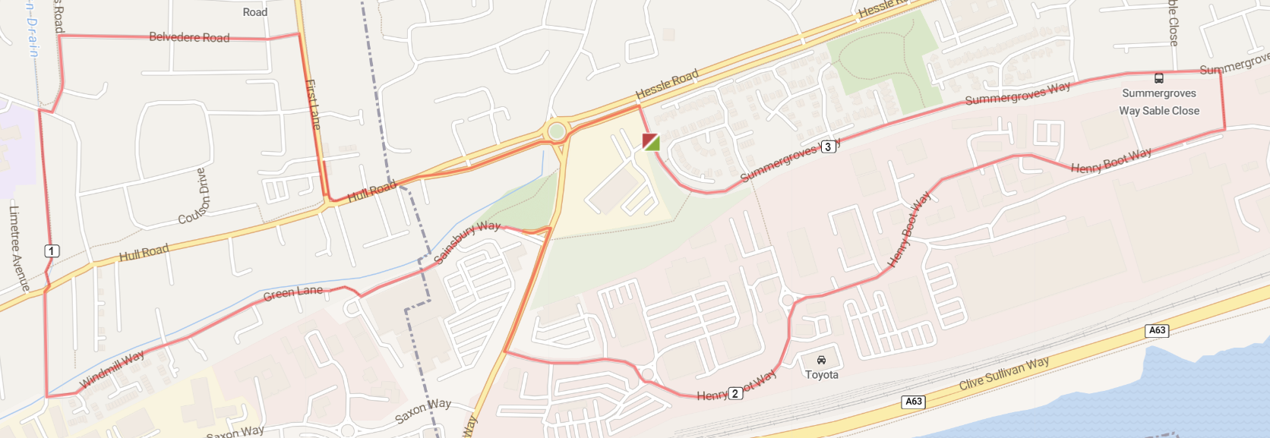
4 | 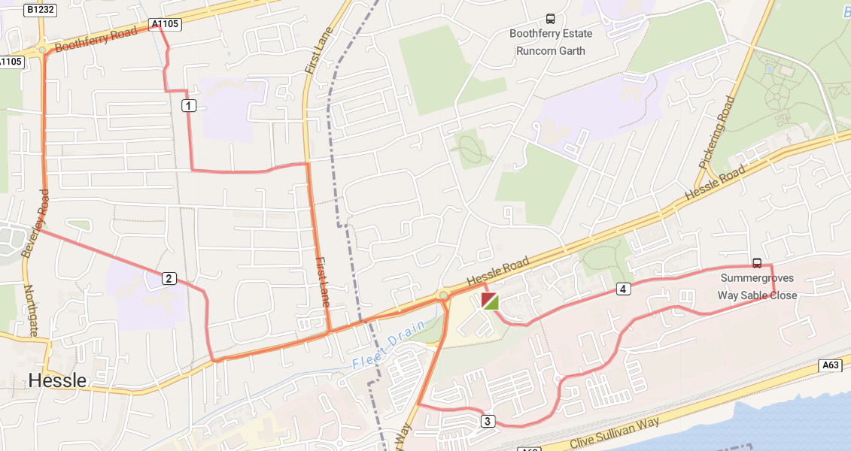
5 | 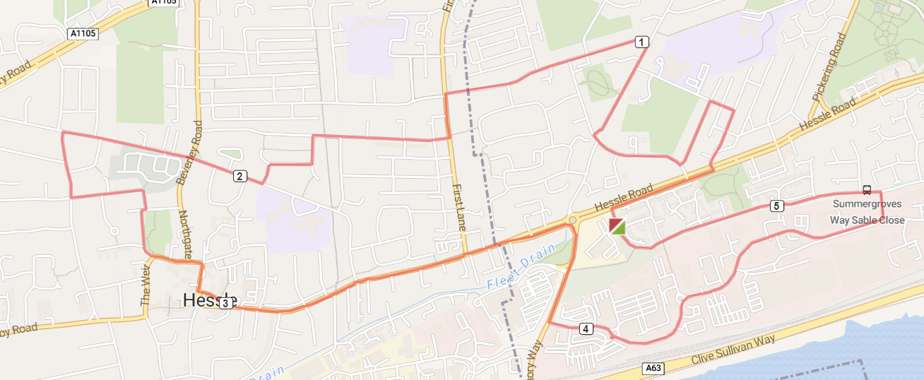
6 | 