MARKET WEIGHTON 5 Mile routes

ROUTE A https://gb.mapometer.com/running/route_5259488.html

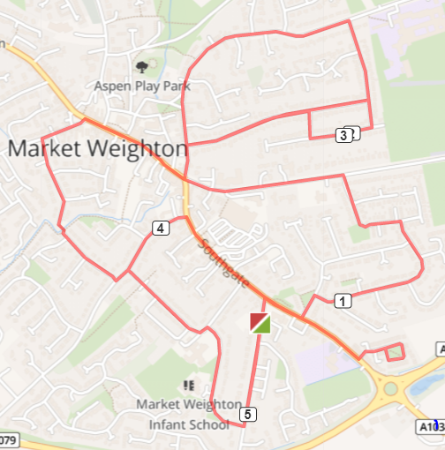

Turn R out of base onto Cliffe Rd. Turn R onto Princess Rd, stay on Princess Rd past the school, bear L, and continue along Princess Rd. Turn R onto Hawlings Rd. (Keep to left side as footpath on left side only at the top) Turn R onto Southgate, Turn L onto Langdale Rd, Turn R onto Beadale Rd, Bear L and onto Lysander Drive, Turn L Beverley Rd until small roundabout, cross over and Turn R Finkle St, Turn R Hill Rise, Turn R Hill Ride Dr, Turn L Hill Rise drive to the top, Turn L Hill Rise Close, Turn L and go down Hill Rise. At the bottom Turn R onto Finkle st. Continue as this turns into Spring Rd. Turn R onto Hill Rise, Continue onto Hill Rise Close, Turn R onto Hill Rise Dr. Continue to Red Salt Bin, Turn R onto Hill Ride Dr. Turn L onto Hill Rise, Turn L Finkle St, Take a R at roundabout onto the High street, which becomes Marketplace, cross at Zebra crossing near Clubleys, L onto Holme Rd. Turn L onto Glenfield Av. Follow to the bottom and cross the mini footbridge, onto Croft Cl. Turn L onto Hawling Rd (Keep to left side as footpath on left side only at the top) Turn R onto Southgate, L onto Kings Ct. do a loop R, L, L, L, Back onto Sancton Rd. Turn R continue & Turn L onto Cliffe Rd Continue up to Princess Rd, cross over and back to base.

Cautions: Uneven surfaces. Use crossings to cross roads.

ROUTE B https://gb.mapometer.com/running/route_5253733.html
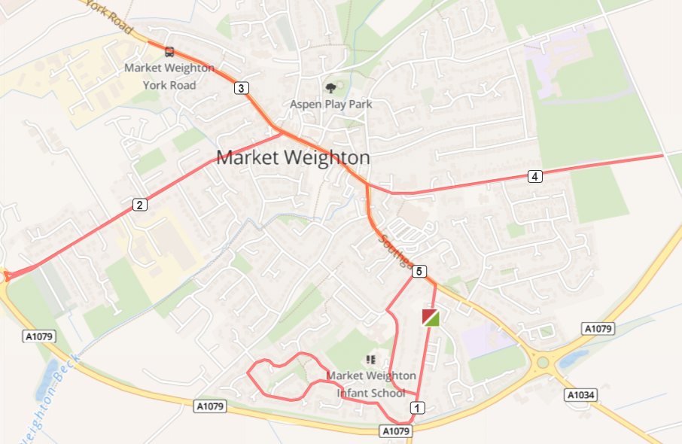

R out of fire station onto Cliffe Rd, continue to end and turn R on shipman Rd, follow all the way round until it meets Crumpton Rd, R onto Crumpton rd, R back onto Shipman Rd, L on Shipman rd, L onto Princess rd, follow round, R princess rd, L southgate - L - High st - Market place, L Holme Rd, follow to bottom, cross at crossing where the vets is, R back up Holme rd, reach Giant Bradley statute, L onto York Rd, continue to Becklands park. RETURN, back onto marketplace, high street, continue at roundabout up Beverley rd, Until Humber street (just past Berties field) cross here and RETURN back down Beverley rd, L at roundabout onto southgate, past Tesco, use crossing, R cliffe rd, back to base.

Cautions: Uneven surfaces. Use crossings to cross roads.

ROUTE C SUMMER https://gb.mapometer.com/running/route_5259501(scenic/ summer)
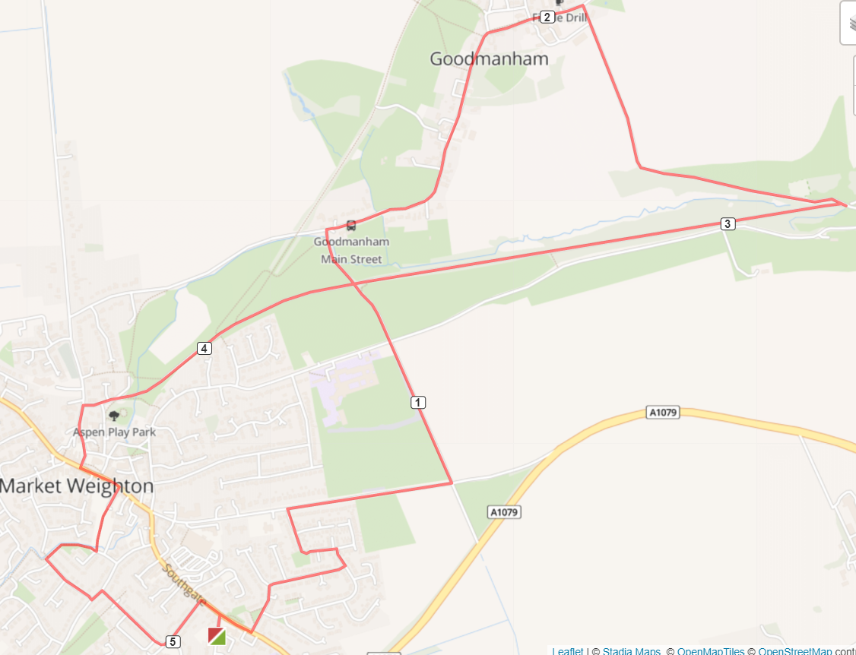

L out of fire station onto Cliffe Rd, R onto Sancton rd, L Wold ave, R Wold Ave, L Beadale rd, R Lysander dr, R Beverley rd, continue up Bev rd, past Berties field, L onto Humber st, Caution uneven surfaces/track, Caution at cross rd, straight on to Red lane, Caution no footpath, Down red lane, R at Windmill house up Goodmanham rd, R past Goodmanham arms, R main st, R onto unnamed rd (house at top) continue all the way down Caution no street lighting/footpath until the cross roads at Hudson way, take R through the gates onto Hudson way, continue past play park onto Hall rd, L Londesborough rd, L market place, cross at crossing, R Providence row (between couplands and post office) Through play park, cross beck, R and follow beck to bridge and L croft close, L hawlings rd, L princes rd, L princess rd, R onto southgate, R cliffe Rd, back to base.

ROUTE D https://gb.mapometer.com/running/route_5253729.html

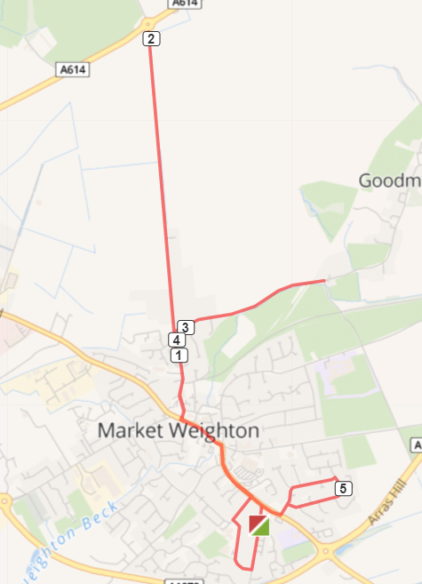
R out of fire station onto Cliffe Rd, R Princess rd, R Princess rd, L Southgate, L at roundabout onto High st - Market place, use crossing to cross, R Londesbrough rd, continue to the top/roundabout where footpath ends, RETURN, L Goodmanham rd onto Windmill house, RETURN on Goodmanham rd, L Londesbrough rd, L market place - High st, R at Roundabout onto Southgate, continue onto Sancton rd, L Langdale rd, R Wold Ave, R Beadale rd, L Langdale rd, R onto Sancton rd, L Cliffe rd back to base.

Cautions: Uneven surfaces, use crossing to cross roads.

ROUTE E https://gb.mapometer.com/running/route_5277367.html

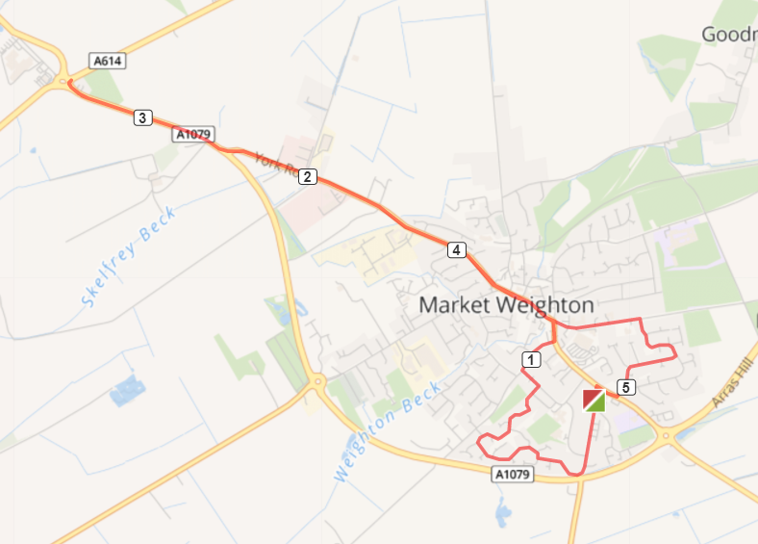
Turn R out of base onto Cliffe Rd, R Shipman Rd at the end of Shipman Rd take the cut through onto Princess cl, L Princess Rd - R Hawling Rd - L Southgate - L at roundabout onto High St, continue onto market place - continue onto York Rd - continue to roundabout . Return back to Beverley Rd. R Lysander Dr. R Beadale Rd, L Landale Rd. R onto Sancton rd, cross at crossing back to base on Cliffe Rd)

Cautions: Uneven surfaces, use crossing to cross roads.

ROUTE F - MW FM 5 Miles Route F . Mapometer.com running route #5396062

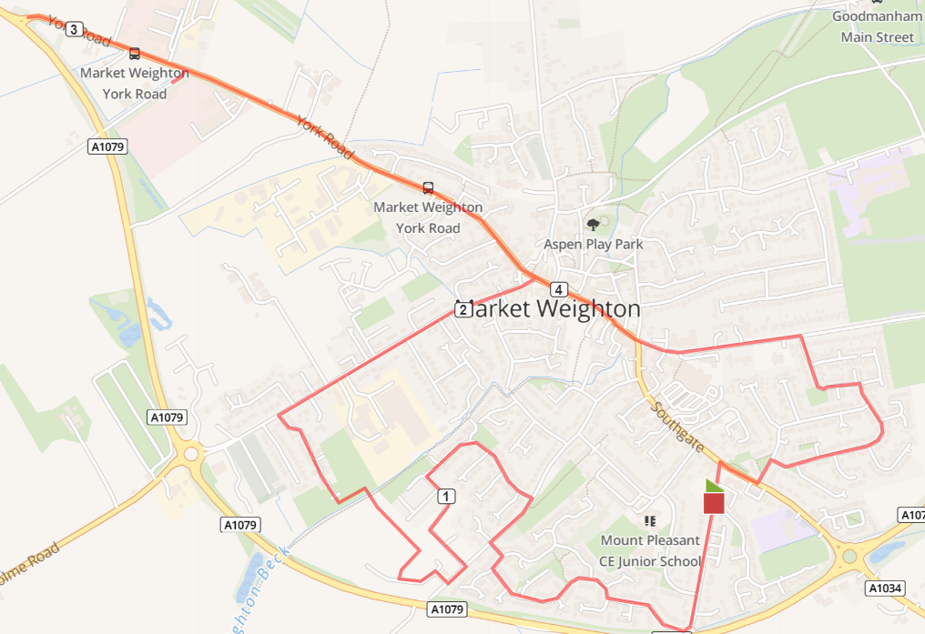

Turn R out of base onto Cliffe Rd, to end bear R Shipman Rd. At T-Junction/ road divide R continue Shipman Rd, T-junction R then L take the snicket pathway through to Sweep Rd (caution bollards, low light) R on Sweep Rd, L onto Wicstun Way. Follow Wicstun Way keeping L until turns in Butler Drive, R Sweep Rd, to end R Ombler Drive, 1st R Beales Close over Weighton Beck, L Coperland Crescent, R Sandholme to end R Holme Rd. At end Holme Rd, cross road L on York Rd continue to roundabout (caution path, light) RETURN York Rd, Market Place, High St, over mini roundabout up Beverley Rd, R onto Lysander Dr, R Bedale Rd, L onto Langdale, R onto Sancton Rd, cross zebra crossing L onto Cliffe Rd back to base
Cautions – bollards, narrow path low light snicket from Shipman to Sweep Lane, uneven pavements along the route, new road surface areas with high kerbs, low light (Beales Close area), narrow path, no light after Becklands Ind est. Road crossings.

