Boothferry Fitmums Running Routes
Route 7 – HFRS Base

L Summergroves caution crossing road, R Hessle Rd, L Graham Ave 3rd road on right continue to end and then right back round to Graham Ave and back to Hessle Rd, R Hessle Rd caution crossing road, L Summergroves HQ  BoothFM - Route 7; 1 mile . Mapometer.com running route #5506582 | 1 mile
L Summergroves, L Hessle Rd onto Hull Rd, L Buttfield Rd, R (Ferry) Station Road, R Southgate, R The Square onto Hull Rd onto Hessle Rd, R Summergroves to HQ  BoothFM - Route 7; 2 miles. Mapometer.com running route #5506584 | 2 miles
L Summergroves, L Hessle Rd, continue onto Hull Rd, R First Lane, L Boothferry Rd, L Beverley Rd, L Northolme Rd, L Hull Rd onto Hessle Rd, R Summergroves, HQ  BoothFM - Route 7; 3 miles.. Mapometer.com running route #5506585 | 3 miles
L Summergroves, R Hessle Rd, L Pickering Rd cross roundabout continue on Pickering Rd, L Park Rd East through snicket, R Park Rd East, L The Link, L Park Lane West, L APRN, L Boothferry Rd, R Pickering Rd, R Hessle Rd, L Summergroves, back to HQ  BoothFM - Route 7; 4 miles.. Mapometer.com running route #5506588 | 4 miles
R Summergroves, L Hessle Road, R Pickering Rd cross roundabout continue on Pickering Rd, L Anlaby Rd, L Plantation Drive, L Woodland End, R Southern Drive, R Holme Close, L Park Lane West, L APRN cross bridge, L Boothferry Rd, R Pickering Rd, R Hessle Rd, L Summergroves to HQ  BoothFM - Route 7; 5 miles. Mapometer.com running route #5506590 | 5 miles
R Summergroves, L Hessle Rd, R Pickering Rd cross roundabout continue on Pickering Rd, L Anlaby Rd, L Plantation Drive, L Woodland End, R Southern Drive, R Holme Close, R Park Lane West, L Coppice Side, L Mead Walk, R APRN, R Anlaby Rd, R Belgrave Drive, L Eastfield Rd, L Belgrave Rd, R Boothferry Rd cross roundabout, L Pickering Rd, L Hessle Rd, R Summergroves to HQ  BoothFM - Route 7; 6 miles. Mapometer.com running route #5506593 | 6 miles

ROUTE 7
1 | 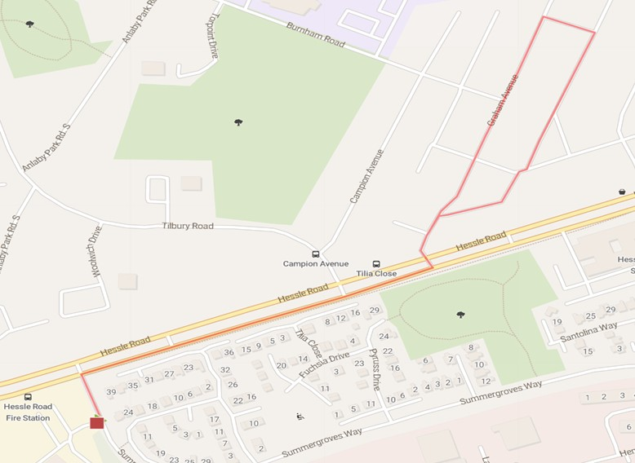
2 | 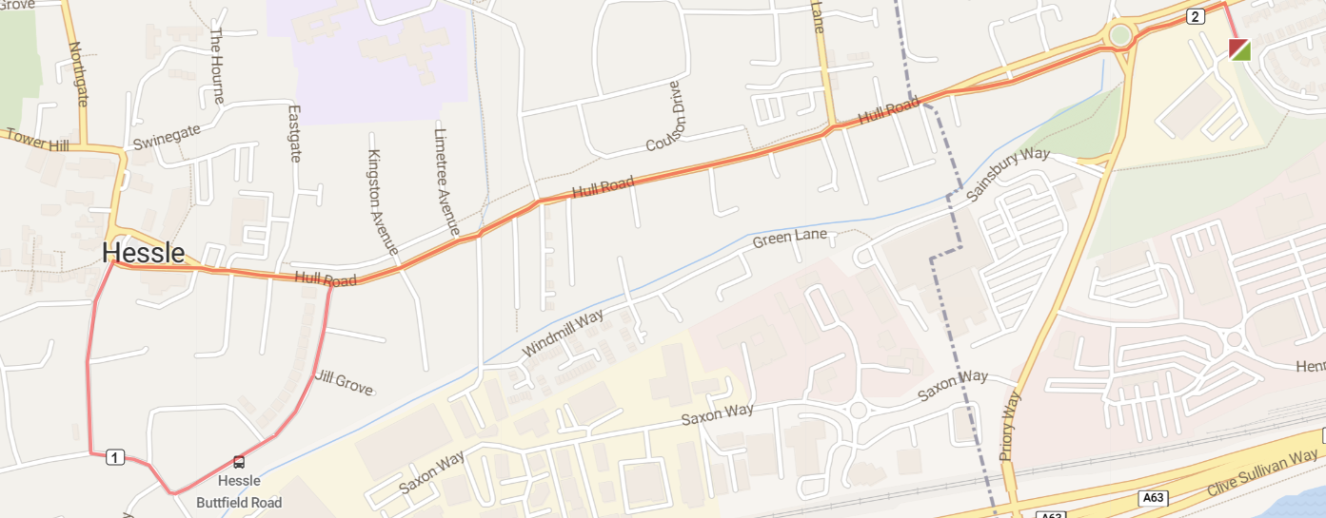
3 | 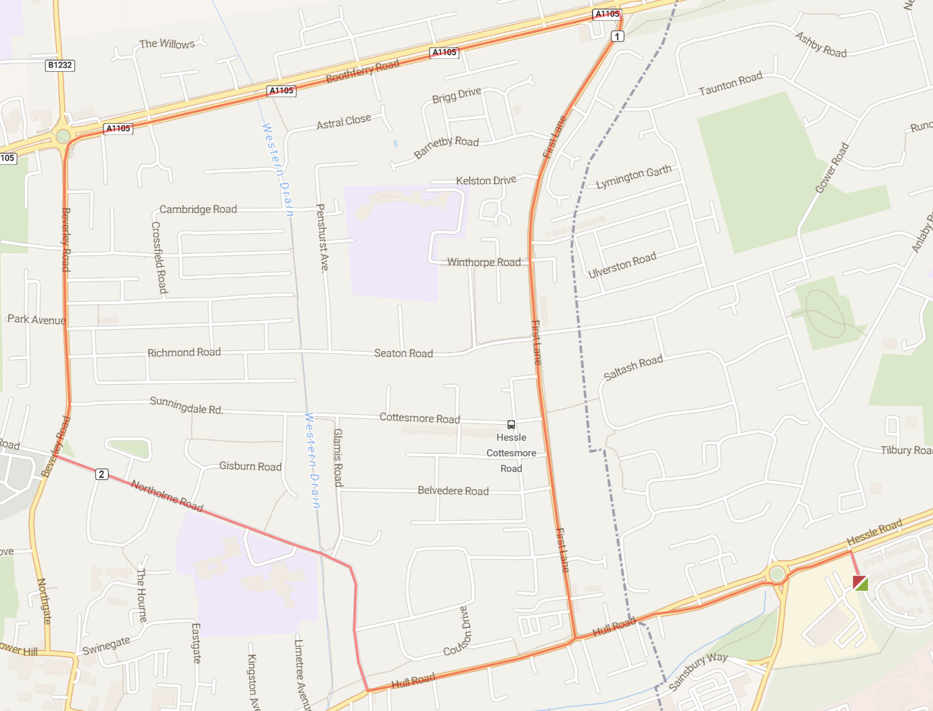
4 | 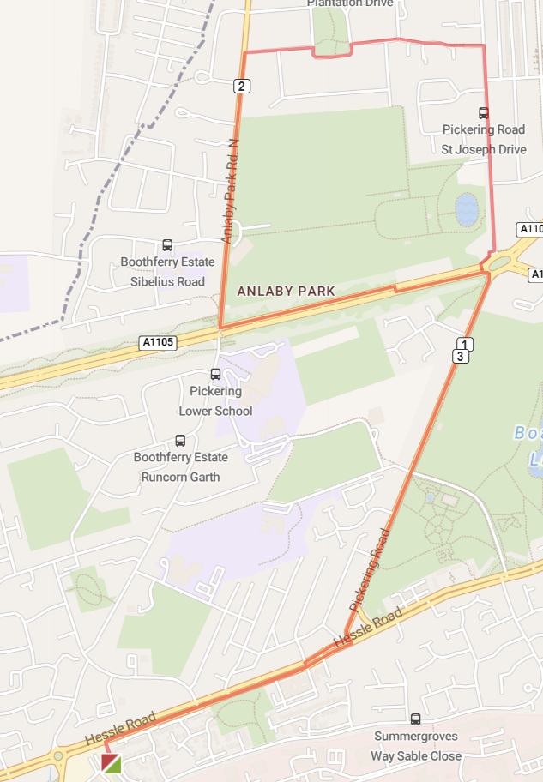
5 | 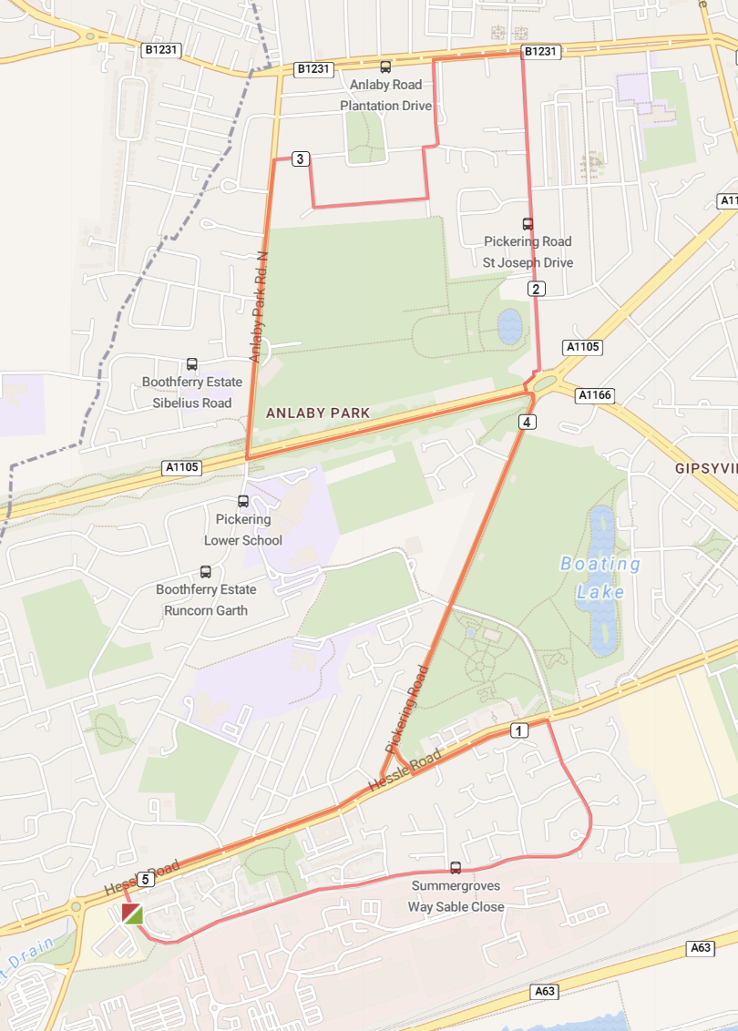
6 | 