Boothferry Fitmums Running Routes
Route 3 – HFRS Base

Exit base and turn L onto Hessle Rd, Caution: use crossing, continue Hessle Rd onto Hull Rd, L Itlings Lane, L Windmill Way, onto Green Lane, onto Sainsburys Way, L Priory Way, R Hessle Rd and back to base. Caution when crossing road.  BoothFM - Route 3; 1 mile. Mapometer.com running route #5499746 | 1 mile
Exit base, turn L onto Hessle Rd, Caution: use crossing, continue Hessle Rd onto Hull Rd, continue into Hessle Square, straight up Prestongate, L The Weir, L South Lane, L Station Rd, onto Ferry Rd, L Buttfield Rd, R Hull Rd, R Itlings Lane, L Windmill Way, onto Green Lane, onto Sainsburys Way, L Priory Way, R Hessle Rd and back to base. Caution when crossing road.  BoothFM - Route 3; 2mile. Mapometer.com running route #5489885 | 2 miles
Exit base, R Summergroves Way, R onto footpath (after passing Sable Close on LHS), R Henry Boot Way, follow road round, L at roundabout stay on HB Way, R Priory Way caution: use crossing, L Sainsburys Way, Green Lane, Windmill Way, R Itlings Lane, cross road with caution, R Hull Rd, L Northolme, R Glamis Rd, R Belvedere Rd, R First Lane, L Hull Rd onto Hessle Rd, caution cross with care  BoothFM - Route 3; 3 miles. Mapometer.com running route #5499745 | 3 miles
Exit base, R Summergroves Way, R onto footpath (after passing Sable Close on LHS), R Henry Boot Way, follow road round, L at roundabout stay on HB Way, R Priory Way caution: use crossing, L Hessle Rd, onto Hull Rd, R Northolme Rd, R Beverley Rd, R Boothferry Rd, R snicket (just after pedestrian crossing) R Astral Close, L Astral Rd, L Cambridge St, R Penshurst Ave, L Seaton Rd, R First Lane, L Hessle Rd, caution cross with care  BoothFM - Route 3; 4 miles. Mapometer.com running route #5499743 | 4 miles
Exit base, R Summergroves Way, R onto footpath (after passing Sable Close on LHS), R Henry Boot Way, follow road round, L at roundabout stay on HB Way, R Priory Way caution: use crossing, L Hessle Rd, onto Hull Rd, into Hessle Sq, R Southgate, L Swinegate onto Tower Hill, R Tower Hill, R Trinity Grove, L Brunswick Grove, L Westbourne Ave, R Barrow Lane, R Swanland Rd onto Northolme Rd, L Gisburn Rd, R and L Gisburn, R Sunningdale Rd, onto Cottesmore Rd, L First Lane, R Bethune Ave, R APRS, L Tilbury Rd, L Campion Ave, R Burnham Rd, R Graham Ave, R Hessle Rd caution cross with care  BoothFM - Route 3; 5mile. Mapometer.com running route #5489891 | 5 miles
Exit base, L Hessle Rd, caution crossing road, onto Hull Rd, into Hessle Sq, R Southgate, L Swinegate, R Northgate, onto Beverley Rd, caution cross at roundabout, continue Beverley Rd, L Tranby Lane, R Croft View, R Woodland Drive, L Beverley Rd, R Springfield Way, R Wolfreton Dr onto Wilson St, L Hull Rd, R First Lane, L snicket onto St Thomas More Rd, L Sibelius Rd, R APRN, caution use crossing, onto APRS, L Tilbury Rd, continue APRS L Hessle Rd caution crossing road  BoothFM - Route 3; 6 miles. Mapometer.com running route #5499740 | 6 miles
ROUTE 3
1 | 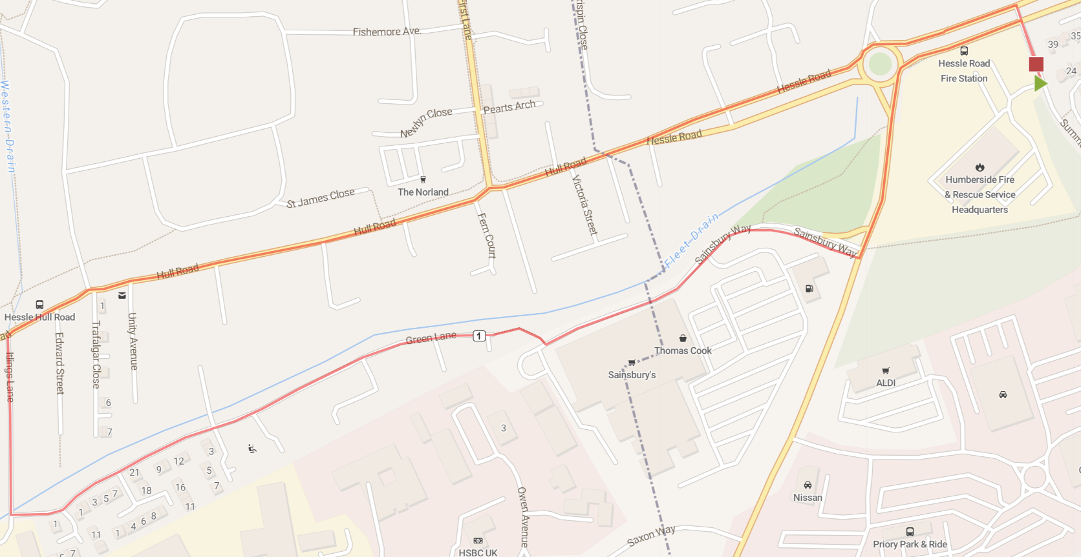
2 | 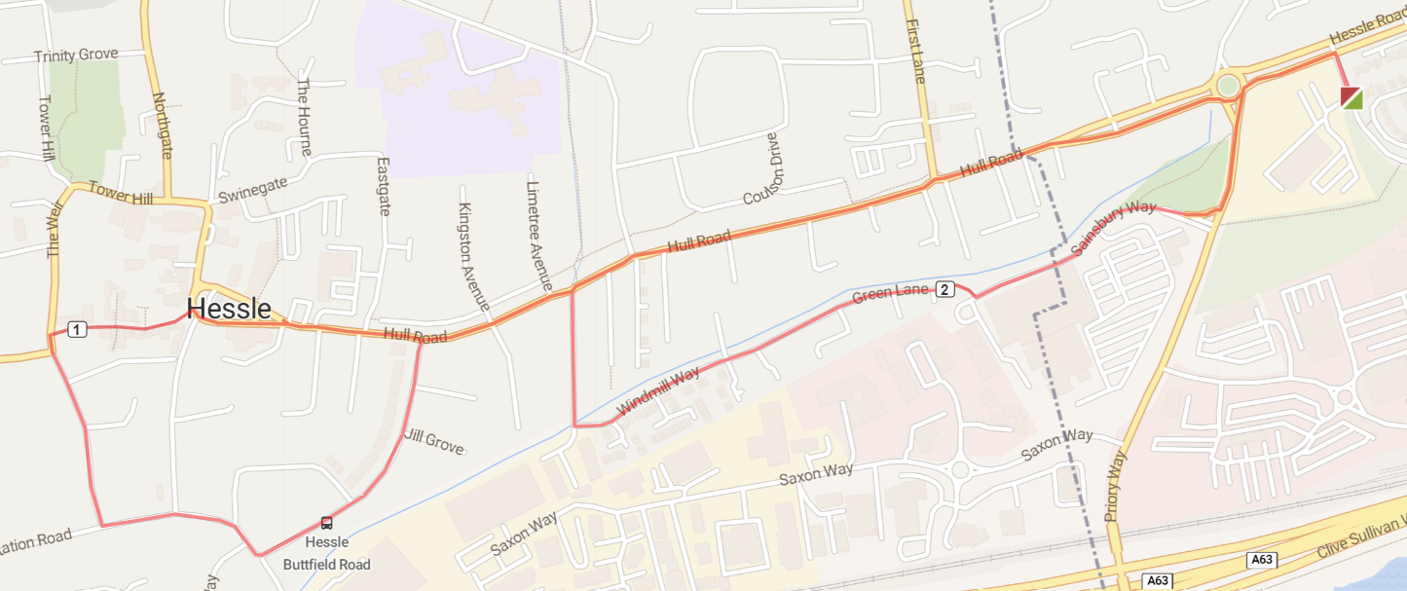
3 | 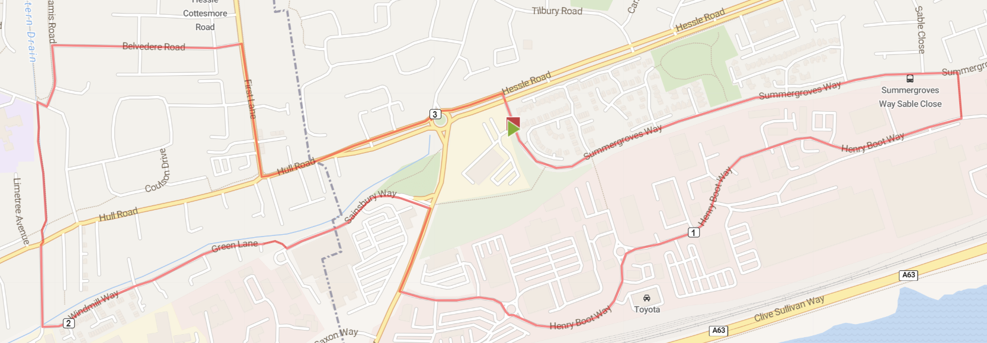
4 | 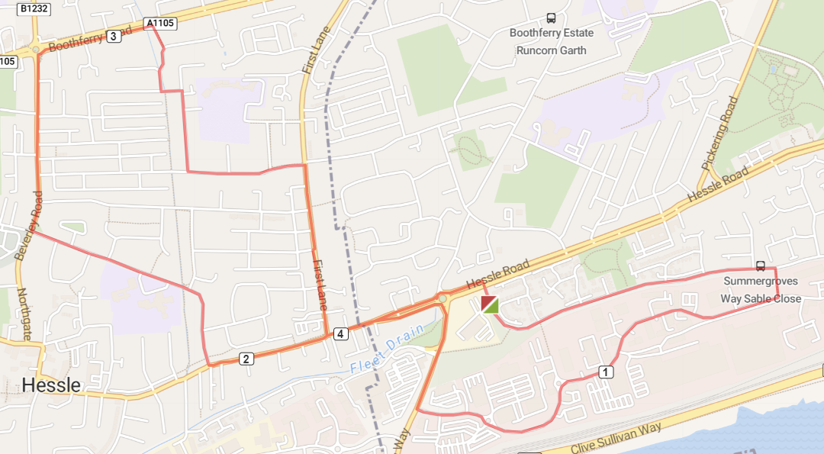
5 | 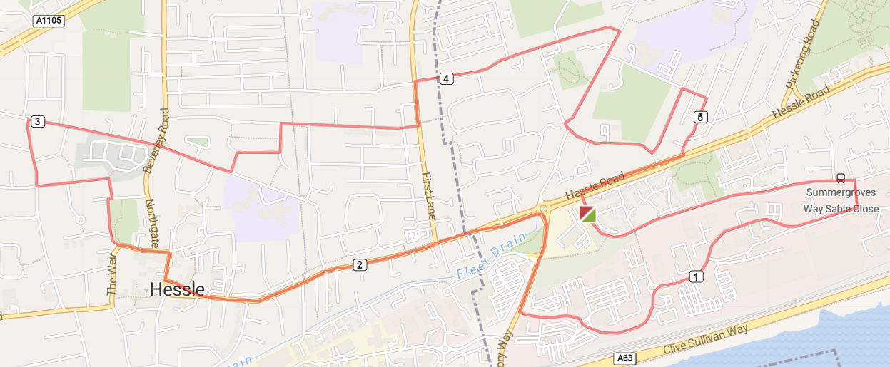
6 | 