Boothferry Fitmums Running Routes
Route 1 – HFRS Base
Exit base and cross to other side of Summergroves Way, Caution crossing road, R Summergroves Way, L Robinia Drive, L Santolina Way, R Summergroves Way nd back to base.  BoothFM - Route 1; 1 mile. Mapometer.com running route #5499758 | 1 mile
Exit base and cross to other side of Summergroves Way, Caution crossing road, R Summergroves Way, cross road, R Forester Way, L Summergroves Way, cross road, R Gemsbok Way, L Impala Way, R Summergroves Way, R Robinia Drive, L Santolina Way, R Summergroves Way and back to base  BoothFM - Route 1; 2 miles. Mapometer.com running route #5499757 | 2 mile
Exit base and cross to other side of Summergroves Way, Caution crossing road, R Summergroves Way, R Hessle Road, Caution use crossing to cross road, L Askew Ave, L Pickering Road, R Hessle Rd, Caution cross road with care, back to base BoothFM - Route 1; 3 miles. Mapometer.com running route #5499756 | 3 mile
Exit base and cross to other side of Summergroves Way, Caution crossing road, R Summergroves Way, L Hessle Rd, Caution – use crossing to cross road, R Pickering Rd, onto Boothferry Road, cross Boothferry Road, Caution: use crossing, R Boothferry Rd, L Belgrave Ave, L Anlaby Road, L Pickering Rd, R Boothferry Rd, Caution: use crossing, L APRS, R Bethune Ave, L Hessle Rd, and back to base. Caution crossing road.  BoothFM - Route 1; 4 miles. Mapometer.com running route #5499755 | 4 mile
Exit base and cross to other side of Summergroves Way, Caution crossing road, R Summergroves Way, R Hessle Road, Caution use crossing , L Askew Ave, L Boothferry Rd, Caution: use crossing, R APRN, L Sibelius Rd, Caution: cross road with care, R St. Thomas More Rd, L First Lane, R Boothferry Rd, Caution: use crossing, L Beverley Rd, L Northolme Rd, L Hull Rd, straight onto Hessle Rd and back to base. Caution: crossing road.  BoothFM - Route 1; 5 miles. Mapometer.com running route #5499754 | 5 mile
Exit base and R onto Hessle Rd, Caution: cross road with care, L Pickering Rd, cross at roundabout, L Boothferry Rd, R APRN, L Rokeby Ave Caution: cross road with care, R Spring Gardens, L Hull Rd, L First Lane, R Boothferry Rd, Caution: use crossing, L Pulcroft Rd, L Swanland Rd, R Beverley Rd, onto Northgate, L Swinegate, onto Eastgate, Caution: narrow paths, follow road round, L Hull Rd, onto Hessle Rd and back to base. Caution: use care crossing road.  BoothFM - Route 1; 6mile. Mapometer.com running route #5489840 | 6 mile

ROUTE 1
1 | 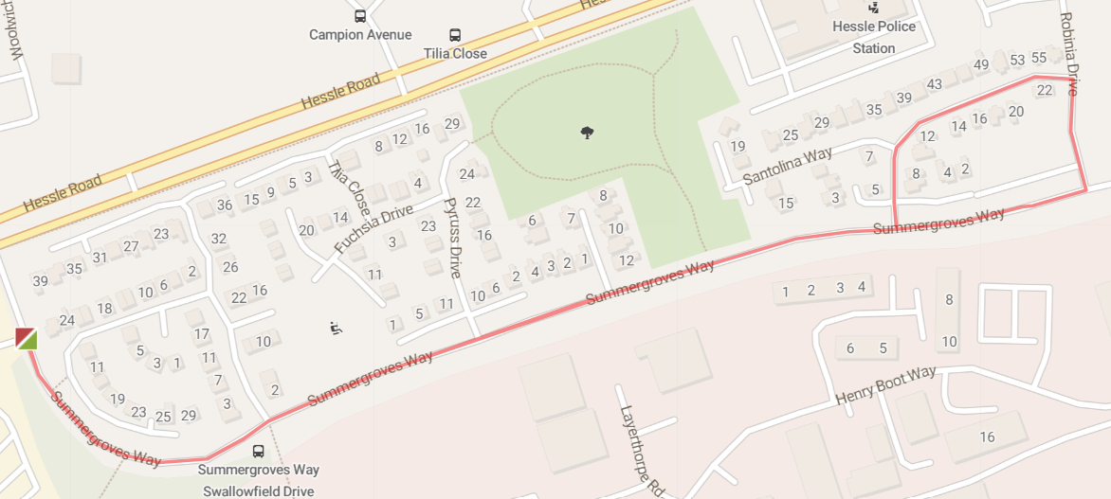
2 | 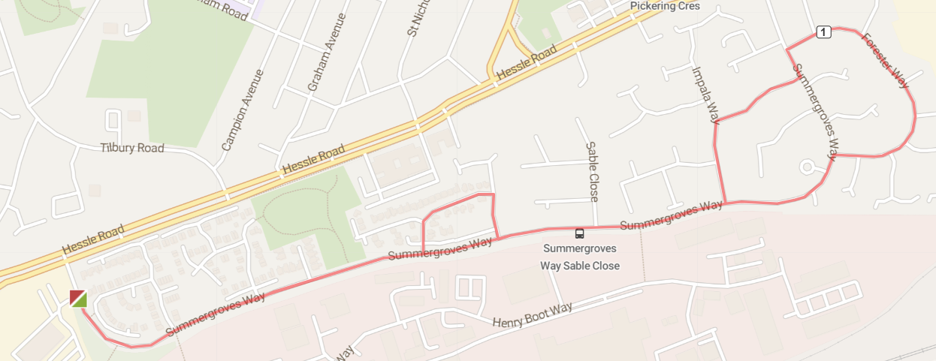

3 | 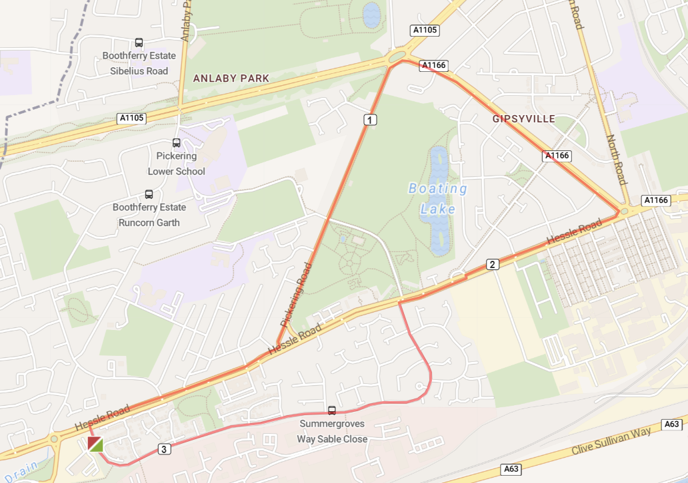
4 | 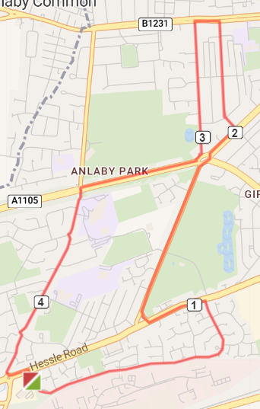
5 | 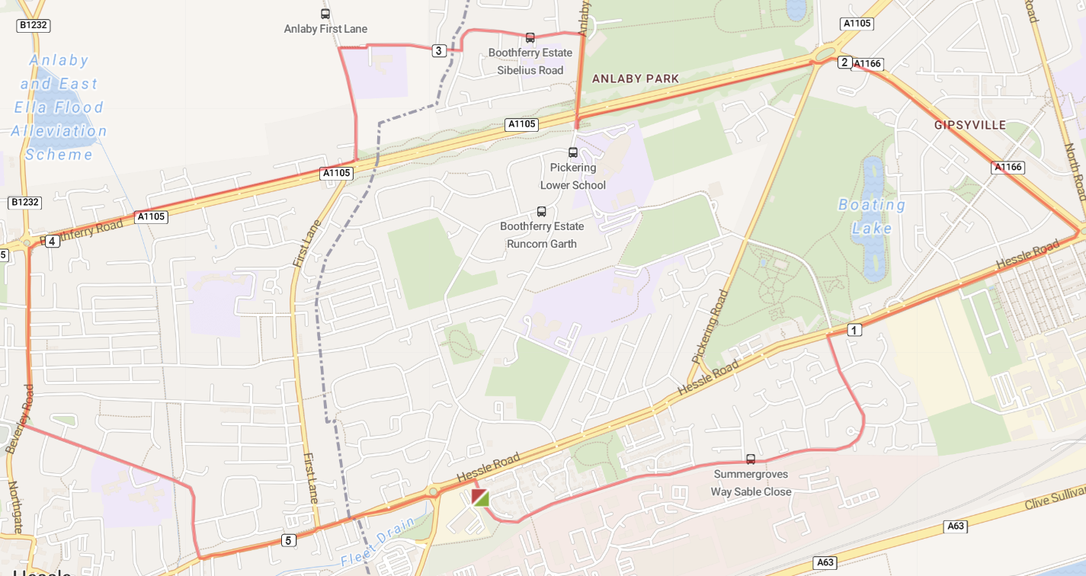
6 | 